
May 2026

Resilience
and reform

© Commonwealth of Australia 2026
ISBN: 978-1-923278-43-1
This publication is available for your use under a Creative Commons Attribution 4.0 International licence, with the exception of the Commonwealth Coat of Arms, photographs, images, third party content, and where otherwise stated. The full licence terms are available from https://creativecommons.org/licenses/by/4.0/legalcode.
Use of Commonwealth of Australia material under a Creative Commons Attribution 4.0 International licence requires you to attribute the work (but not in any way that suggests that the Commonwealth of Australia endorses you or your use of the work).
Commonwealth of Australia material used ‘as supplied’
Provided you have not modified or transformed Commonwealth of Australia material in any way including, for example, by changing the Commonwealth of Australia text; calculating percentage changes; graphing or charting data; or deriving new statistics from published Commonwealth of Australia statistics – then Commonwealth of Australia prefers the following attribution:
Source: The Commonwealth of Australia.
Derivative material
If you have modified or transformed Commonwealth of Australia material, or derived new material from those of the Commonwealth of Australia in any way, then Commonwealth of Australia prefers the following attribution:
Based on Commonwealth of Australia data.
Use of the Coat of Arms
The terms under which the Coat of Arms can be used are set out on the Department of the Prime Minister and Cabinet website (see www.pmc.gov.au/government/commonwealth-coat-arms).
Other uses
Enquiries regarding this licence and any other use of this document are welcome at:
Manager
Media Unit
The Treasury
Langton Crescent
Parkes ACT 2600
Email: media@treasury.gov.au
Internet
A copy of this document is available on the central Budget website at budget.gov.au.
Aboriginal and Torres Strait Islander people are advised that this publication may contain images of deceased people.
Treasury acknowledges the Traditional Custodians of country throughout Australia and their connections to land, sea and community. We pay our respects to their Elders past and present and extend that respect to all Aboriginal and Torres Strait Islander peoples today.

Contents
Resilience and reform 4
Key Budget initiatives 5
Budget at a glance 7
Responsible economic and fiscal management 8
Global economic outlook 10
Domestic economic outlook 11
Responding to the global oil shock 12
Boosting Australia’s fuel security 13
Strengthening supply chains 15
Building resilience 16
Taking pressure off Australians 18
New tax cuts to help with the cost of living 19
Helping with the cost of fuel 22
More homes and a fair go for first home buyers 23
More affordable and accessible healthcare 25
Growing wages 26
Making our economy more productive 27
Delivering on our productivity agenda 28
Reducing the regulatory burden 31
Tax reform for workers, businesses and future generations 32
A better tax system for workers, first home buyers and future generations 33
A better tax system for businesses 35
A simpler and more sustainable tax system 37
Strengthening care and broadening opportunity 39
Securing the NDIS for future generations 40
Better care for older Australians 41
Strengthening Medicare 42
Broadening opportunity and increasing equality 43
Building a resilient and secure Australia 45
Future Made in Australia 46
A record funding boost for defence 47
Building infrastructure for the future 48
Responding to the Bondi attack 49
Appendices 50
Appendix A: Budget aggregates 51
Appendix B: Revenue and spending 53
Appendix C: Major initiatives 54
Appendix D: Major Budget improvements 56
Appendix E: Detailed economic forecasts 57

Resilience and reform

Building an economy that works for all Australians
The conflict in the Middle East has severely disrupted global oil supplies and is contributing to higher inflation, slower growth and extreme economic uncertainty at home and abroad. At the same time, there are big structural changes unfolding in areas like energy and technology, and longstanding challenges when it comes to productivity, intergenerational equity and access to home ownership that demand our attention.
This Budget is about getting us through the global oil shock and taking pressure off Australians, while continuing to build a stronger economy, better tax system, fairer housing market and a more sustainable budget.
Australia is not immune from the impacts of the conflict in the Middle East and the economic consequences will continue to be felt for some time. Disrupted global production and shipping of fuel, petrochemicals and other products have led to higher petrol, diesel, urea, fertiliser and plastic prices. This will add to inflationary pressures and weigh on growth in real incomes and household consumption.
Despite the substantial economic impacts of the global oil shock, Australia confronts these challenges from a position of relative strength. The Australian economy is growing faster than every major advanced economy. Unemployment remains low, the participation rate remains high, wages growth is solid and our public finances are among the strongest in the developed world, with gross debt lower than every major advanced economy.
The Government is strengthening the budget and building on our responsible approach to fiscal management. In every year of the projection period, the budget is stronger and debt is lower. This outcome was only possible because the Government found $63.8 billion of savings and reprioritisations.
The Government is helping Australians now and building Australia's future by:
- Responding to the global oil shock
- Taking pressure off Australians
- Making our economy more productive
- Delivering tax reform for workers, businesses and future generations
- Building a stronger and more sustainable budget

Key Budget initiatives

Responding to the global oil shock
- One billion extra litres of petrol and diesel secured so far for March to June
- $7.5 billion Fuel and Fertiliser Security Facility to secure more fuel from international partners
- $3.2 billion Australian Fuel Security Reserve to build long-term fuel resilience
- $1 billion in interest-free loans to help manufacturing and logistics businesses
- Reserving 20 per cent of gas exports for Australians

Taking pressure off Australians
- $250 Working Australians Tax Offset and a $1,000 instant tax deduction on top of three legislated rounds of tax cuts
- $2 billion for local housing infrastructure to support up to 65,000 new homes
- $2.9 billion to more than halve the fuel excise and reduce the heavy vehicle road user charge to zero for three months
- $5.9 billion to cut the cost of life-saving medicines

Making our economy more productive
- Cutting regulatory burden by $10.2 billion per year
- Faster environmental and low-risk foreign investment approvals to accelerate new projects
- Building a Single National Market, increasing long-run annual GDP by around $13 billion
- Investing $1.5 billion in our research and scientific institutions

Tax reform for workers, businesses and future generations
- Cutting taxes for more than 13 million Australian workers
- Helping more Australians achieve home ownership through reforms to support an additional 75,000 homeowners
- Over $3.5 billion in new measures that lower taxes for businesses and start-ups, including loss refundability and a permanent $20,000 instant asset write-off
- A simpler and more sustainable tax system, with combined annual compliance savings of over $500 million for workers and businesses

Strengthening care and broadening opportunity
- A landmark $25 billion additional investment for public hospitals
- $1.8 billion to make Medicare Urgent Care Clinics permanent
- $3.7 billion to provide more beds, more support packages and better care for older Australians
- $182.6 million to make the Child Support Scheme safer and more effective

Building a resilient and secure Australia
- Releasing $1.1 billion to support domestic production of low emissions fuels
- A record additional $53 billion investment in Defence capabilities
- $8.6 billion for nationally significant road and rail projects
- $604.2 million to address hate speech, violent extremism and terrorism

Budget at a glance

Responsible economic management
The Government’s responsible economic management has delivered a stronger and more sustainable budget, with lower deficits and less debt.
The budget is $44.9 billion stronger over the forward estimates than the mid-year update and more than a quarter of a trillion dollars better over the eight years to 2029–30 than the estimate the Government inherited.
Gross debt peaks earlier and lower, and is lower in every year compared to the mid-year update. Gross debt peaks 1.2 percentage points lower than the mid-year update and is $173 billion lower in 2026–27 than the estimate at the 2022 PEFO.
The Government’s fiscal management is underpinned by savings and reprioritisations, spending restraint and banking revenue upgrades. These actions mean this Budget is helping to take the pressure off inflation and delivering substantial improvements in the fiscal position over time. In this Budget, the Government is saving more than we are spending, with net decisions positive for the second consecutive update. Net decisions are $26.1 billion when accounting for the responsible provisions made in previous updates.
Budget at a Glance
Underlying cash balance | Estimates  2025–26 | Estimates  2026–27 | Estimates  2027–28 | Estimates  2028–29 | Estimates  2029–30 | Projections  2036–37
$ bn | -28.3 | -31.5 | -31.0 | -34.4 | -25.3
Per cent of GDP | -1.0 | -1.0 | -1.0 | -1.0 | -0.7 | 0.8
Per cent of GDP at MYEFO | -1.3 | -1.1 | -1.1 | -1.1 | -1.5
Budget at a Glance
Gross debt | Estimates  2025–26 | Estimates  2026–27 | Estimates  2027–28 | Estimates  2028–29 | Estimates  2029–30 | Projections  2036–37
$ bn | 982.0 | 1,051.0 | 1,120.0 | 1,193.0 | 1,249.0
Per cent of GDP | 33.1 | 34.0 | 35.2 | 35.8 | 35.6 | 27.2
Per cent of GDP at MYEFO | 34.0 | 35.4 | 36.1 | 36.4 | 36.8

Responsible economic and fiscal management

A stronger and more sustainable budget in more uncertain times
At a time of heightened global economic uncertainty, the Government’s responsible economic and fiscal management has delivered:
- Lower deficits and debt in every year compared to MYEFO and the budget we inherited.
- Improvements in the budget position of $44.9 billion over the forward estimates since MYEFO and more than a quarter of a trillion dollars since coming to Government.
- A lower projected peak in gross debt from 44.9 per cent of GDP in the 2022 PEFO to 35.8 per cent of GDP – a reduction of 9.1 percentage points of GDP.
- Lower nominal gross debt by $173 billion in 2026–27, helping to avoid more than $70 billion in interest costs.
- $63.8 billion of savings and reprioritisations, taking the total since coming to Government to $177.9 billion.
- Net policy decisions are positive for the second consecutive update.
- Every dollar of revenue upgrade has been returned for the second consecutive update.
- Average real payments growth of just 1.5 per cent per year over the eight years to 2029–30, less than half the 30-year average.
By taking action on structural spending pressures, payments as a share of the economy are forecast to fall from 26.8 per cent of GDP in 2026–27 to 26.2 per cent in 2029–30.
These actions mean that the budget is stronger now and into the future. The budget is projected to return to balance in 2034–35 and gross debt as a share of the economy is expected to be less than 30 per cent by the end of the medium term.
Gross debt-to-GDP – now vs 2025–26 MYEFO and 2022 PEFO
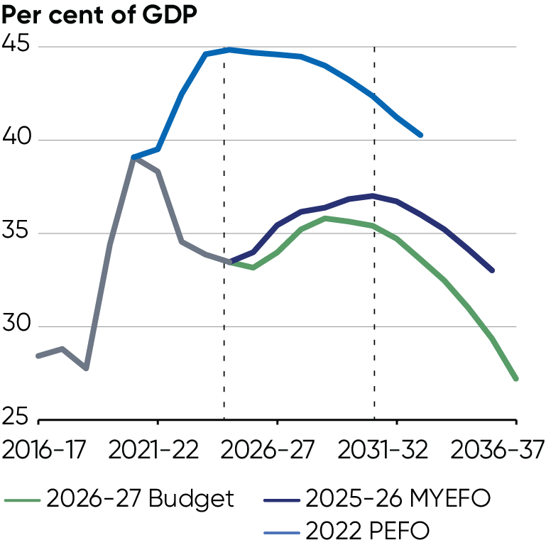
Source: Australian Office of Financial Management, Treasury

Global economic outlook

Extreme global volatility from the war in the Middle East
The conflict in the Middle East has created extreme uncertainty and volatility in the global economy and it is already having a substantial impact. The current conflict has resulted in the largest global oil supply disruption on record. Many other global supply chains have also been impacted, including for fertiliser, chemicals, aluminium and plastics. This will result in higher global inflation and lower global growth, with the scale of impact depending on the duration and severity of the conflict.
Global growth is forecast to be 3 per cent in 2026, following growth of 3.5 per cent in 2025. Assuming an easing in global oil prices from mid-2026, global growth is expected to pick up to be 3¼ per cent in 2027 and 2028.
The global economy faces downside risks, especially from the duration and severity of the Middle East conflict, but also from fiscal vulnerabilities, more protectionist trade policy settings and other geopolitical risks. But, there are upside risks to the outlook for global investment from AI and the renewable energy transition.
Fall in global oil production following major geopolitical shocks
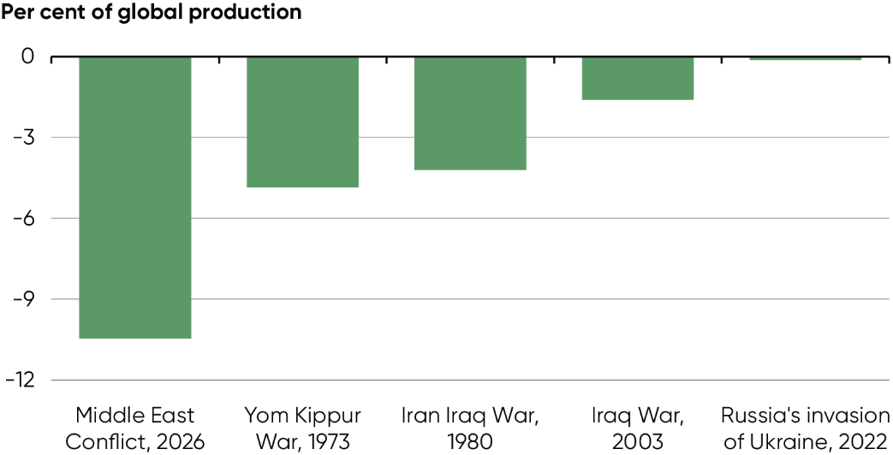
Source: EIA; Treasury
Note: Fall in global crude oil production as a share of total global production, one month after the onset of each conflict.

Domestic economic outlook

Australia is not immune, but confronts these challenges from a position of relative economic strength
Australia is not immune from the impacts of the conflict in the Middle East and the resulting supply shock, and the economic consequences will continue to be felt for some time. The conflict has compounded cost pressures for households and businesses, and is straining some supply chains.
Against this backdrop, inflation is forecast to be 5 per cent through the year to the June quarter 2026, with most of the pick up this year attributable to the sharp rise in oil prices. Higher prices are expected to weigh on activity, with economic growth in Australia forecast to slow from 2¼ per cent in 2025–26 to 1¾ per cent in 2026–27.
Despite the substantial economic impacts of the global oil shock, Australia confronts these challenges from a position of relative strength. The Australian economy is growing faster than every major advanced economy. Unemployment remains low, the participation rate continues to be high and wages growth is solid. Our public finances are set to remain amongst the strongest in the developed world, with gross debt lower than every major advanced economy. Growth is expected to recover in 2027–28 to 2¼ per cent, driven by a recovery in real household incomes.
Australia’s real GDP growth with forecasts  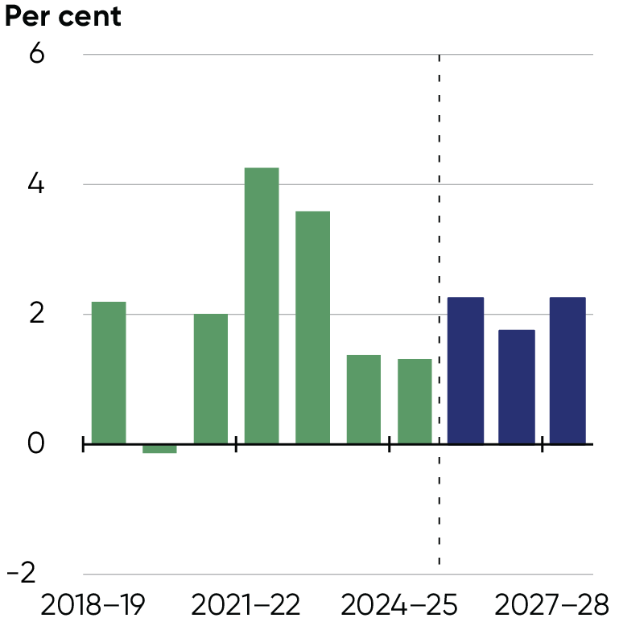 | Australia's unemployment rate with forecasts  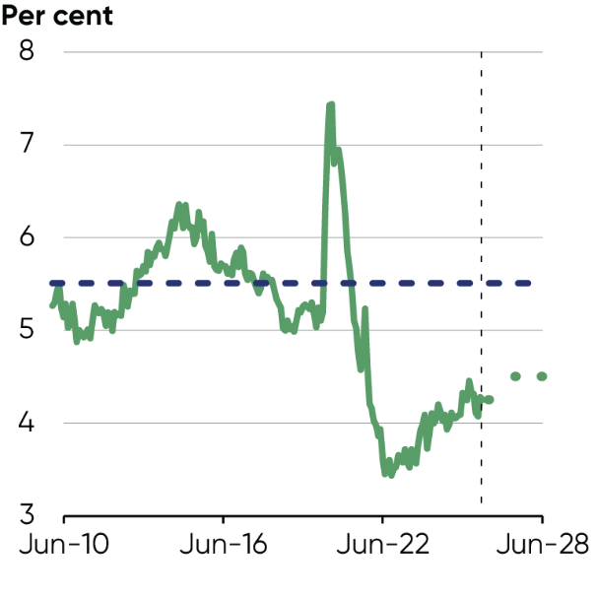
Source: ABS Australian National Accounts: National Income, Expenditure and Product and Treasury | Source: ABS Labour Force Survey and Treasury.  Note: ABS Dashed line indicates 2010–19 average.

Responding to the global oil shock
$7.5 billion Fuel and Fertiliser Security Facility supporting additional supply and storage
Boosting the Minimum Stockholding Obligation for all fuel types
$3.2 billion to establish the Australian Fuel Security Reserve and bring our total stocks of diesel and jet fuel to 50 days
Over 450 million litres of diesel and 100 million litres of jet fuel secured by Export Finance Australia
757 million litres of fuel supplied from the Minimum Stockholding Obligation release
Up to 100 million more litres of petrol per month through changes to fuel standards
$1 billion in interest-free loans for affected manufacturing and logistics businesses
$55 million to move more freight by rail and sea
New ACCC powers to enable faster, coordinated industry responses during exceptional circumstances
Releasing $1.1 billion in support for domestic production of low carbon liquid fuels
$40 million to roll out more kerbside and regional EV chargers
$40.5 million to electrify Australia Post's delivery fleet
Establishing a 20 per cent domestic gas reservation

Boosting Australia’s fuel security
1 billion extra litres of petrol and diesel secured so far for March to June
Over $10 billion committed to securing fuel and fertiliser supplies
50 days of critical diesel and jet fuel in our reserves
The crisis in the Middle East has disrupted global oil supply. The Government is strengthening Australia's fuel supply now and into the future through our $14.8 billion Strengthening Australia's Fuel Resilience Package.

Securing fuel and fertiliser now
The Government has secured more than a billion extra litres of fuel so far for March to June by relaxing the Minimum Stockholding Obligation, underwriting additional cargoes and adjusting fuel standards, and enabling more Australian-produced fuels to be used here.
Fuel and fertiliser shipments are en route to Australia through the new $7.5 billion ($5 billion USD) Fuel and Fertiliser Security Facility. So far, Export Finance Australia has secured over 450 million litres of additional diesel and around 100 million litres of additional jet fuel through this facility.

Building up reserves for the future
We are also taking action to protect Australia's fuel supplies in the long term. The Government is expanding the Minimum Stockholding Obligation with an additional ten days supply for diesel, jet fuel and petrol. We are establishing the $3.2 billion government-controlled Australian Fuel Security Reserve, which will hold around 1 billion litres of diesel and jet fuel to provide an additional buffer during any future crisis. Together through these efforts, Australia will increase its diesel and jet fuel reserves to 50 days.
We have strengthened the Fuel Security Services Payment to protect the future of our two refineries and committed $10 million for feasibility studies into expanding our domestic refining capacity. We are also providing $34.7 million to manage Australia’s fuel security framework, including oversight of the Fuel Security Services Payment and the Minimum Stockholding Obligation.

Ensuring a coordinated national response
The Government is facilitating an orderly response to the international supply chain disruptions, coordinating planning across states and territories and strengthening our trading partnerships. The National Fuel Security Plan agreed by National Cabinet establishes a coordinated four-stage approach to safeguarding Australia's fuel supply, supported by the Fuel Supply Taskforce.
To raise awareness of the National Fuel Security Plan and to help Australians feel prepared and supported, the Government has launched the National Fuel Security Campaign. The campaign encourages Australians to adopt simple, practical behaviours to use less fuel, helping our supply go further and saving fuel for our truckies, farmers and essential services.

Relieving immediate pressure on fuel users
To keep our trucks, trains and planes moving and critical production online, the Government is helping manufacturing and logistics businesses manage cashflow pressures with interest-free loans from the National Reconstruction Fund's (NRF) $1 billion Economic Resilience Program. This complements the $5 billion committed to the NRF’s Net Zero Fund since last Budget. We have also more than halved the fuel excise and reduced the heavy vehicle road user charge to zero for three months, and deferred full cost recovery arrangements for agricultural export services.
To support supply chain efficiency, the Government will streamline the Australian Competition and Consumer Commission's (ACCC) powers to allow industry to better coordinate during exceptional circumstances. The Government has also empowered the Fair Work Commission to make orders to support more timely adjustments to fuel terms in road transport contracts, supporting small business.
To support businesses’ and individuals' purchasing options, the Government has increased reporting on fuel availability and prices through ACCC and Fuel Supply Taskforce reporting. We are also regularly engaging with industry through the Taskforce and other forums to ensure the policy response is timely, well targeted and appropriate.

Strengthening supply chains
250,000 tonnes of agricultural urea for Australian farmers
Australia’s economy depends on secure and reliable supply chains. In a more volatile global environment, the Government is taking targeted action to keep essential goods moving while strengthening resilience for the future. This approach focuses on early action, close partnership with industry, and interventions that support markets rather than replace them.

Strengthening partnerships with trading partners
The Government is working with businesses and international partners to maintain access to critical inputs during periods of global disruption. Since the conflict in the Middle East began, the Government has facilitated supply of 250,000 tonnes of agricultural urea for Australian farmers and signed landmark supply chain commitments with Japan, the Republic of Korea, Singapore, Malaysia and Brunei Darussalam, keeping critical goods flowing despite global instability.

Improving freight resilience
Moving more freight by rail or ship improves fuel efficiency and supply chain resilience.
The Government is providing $55 million for a Transport Resilience and Capacity Kickstart pilot program to incentivise greater volumes of ship and rail freight. We will also progress improvements to interstate rail operations and connectivity, and biosecurity border processes will be streamlined to help get fertiliser to farms faster.
The Government will accelerate heavy vehicle reforms through National Competition Policy to increase heavy vehicle transport productivity and support the uptake of zero emissions heavy vehicles.

Building resilience
20% of gas exports reserved for Australian gas users
Over 100,000 electric vehicles supported by the Electric Car Discount
The Government is improving Australia’s longer-term resilience to energy shocks, securing more affordable gas and shielding Australians from the worst impacts of climate change through our transition to net zero. Australians will have more choice in how they power their homes, businesses and vehicles, reducing their dependence on imported fuels and vulnerability to high global energy prices.

Building energy sovereignty
Australia continues to take steps to secure greater energy sovereignty, delivering 6.8 gigawatts of renewable energy in 2025 and more than 370,000 home batteries through the Cheaper Home Batteries program since 1 July 2025, providing over 10 gigawatt hours of new capacity. Over 4 million households currently generate their own solar energy, and two million are expected to have a battery by 2030.
In this Budget, the Government is announcing a 20 per cent domestic gas reservation so that LNG exporters supply a proportion of production to the domestic market. The domestic reservation scheme will commence on 1 July 2027, with final consultation on legislation throughout June and July. This will ensure Australian gas users have access to a stable and affordable supply of energy and will grow our energy resilience and industrial capabilities.
Alongside implementation of a domestic gas reservation, the Government will streamline gas regulatory frameworks, with the reservation superseding the Australian Domestic Gas Security Mechanism and Heads of Agreements, and enabling further reform to the Gas Market Code.

Making more clean fuels here
Diversifying our energy supply away from imported fuels will improve our economy's resilience to future oil shocks. The Government is delivering the $1.1 billion Cleaner Fuels Program to provide production support to the domestic low carbon liquid fuels industry. We are also progressing the $1 billion Round 2 of the Hydrogen Headstart program to provide revenue support for large-scale renewable hydrogen projects.
We are continuing to develop a domestic low carbon liquid fuel industry, along with a green fuel bunkering strategy. Working with industry, we will introduce a demand measure that provides certainty for new Australian low carbon liquid fuel production and stimulates investment in new, clean fuel refining capacity. This will reduce our reliance on imported fuels, improving the resilience of our domestic transport industry.

Electrifying freight and transit
The Government will transition the arrangements to support electric cars to a permanent 25 per cent fringe benefits tax (FBT) discount for eligible electric cars costing over $75,000 from 1 April 2027 and for all eligible electric cars from 1 April 2029. Electric cars costing up to $75,000 will continue to receive a full FBT exemption, provided the arrangement commences before 1 April 2029. Existing arrangements will not be affected. All eligible cars will retain the FBT discount in place when the fringe benefit arrangement starts, for the life of the arrangement.
These changes reflect the recommendations of the statutory review of the electric car discount policy and will further incentivise the supply of more affordable electric cars while moving to more sustainable settings for the future.
We are supporting Australia Post to electrify its delivery fleet with a further $40.5 million investment. This adds to work underway to make it easier for Australians to charge their electric vehicles by committing $40 million to install more kerbside and regional chargers.

Taking pressure off Australians
A new tax cut for working Australian taxpayers through the $250 Working Australians Tax Offset
A new $1,000 instant tax deduction for Australian workers, with an average saving of $205 for 6.2 million workers for 2026–27
Legislated tax cuts starting 1 July this year and next year, worth up to $536, on top of the first round of tax cuts delivered in 2024
Combined, permanent cost-of-living relief of up to $2,816 per year from 2027–28 for an Australian worker on average earnings, relative to 2023–24 settings
Reforming the tax system to make it easier for Australians to own their own home
$2.9 billion to more than halve the fuel excise and reduce the heavy vehicle road user charge to zero for three months
Empowering the ACCC by doubling competition and consumer law penalties to a maximum of $100 million
Increased ATO flexibility for businesses unable to meet their tax obligations due to fuel supply issues
$2 billion to build critical 'last mile' infrastructure needed for new housing developments, supporting up to 65,000 new homes and taking the total housing agenda to over $47 billion
$59.4 million to support secure housing for over 4,000 young people at risk of homelessness
$1.8 billion to make Medicare Urgent Care Clinics a permanent feature of Australia's health system. These clinics have delivered almost three million free visits nationwide
$5.9 billion to make medicines more affordable through new and amended listings on the PBS for cystic fibrosis, chronic kidney disease, various cancers and more
$9,120 in higher wages for low-paid workers through Annual Wage Review decisions

New tax cuts to help with the cost of living
$250 new tax offset for Australian workers from 1 July 2027
$1,000 instant tax deduction for workers from 2026–27
Up to $2,816 benefit for an Australian worker on average earnings from five tax cuts

A new tax cut for every Australian worker
The Government is delivering new tax cuts for every working Australian taxpayer. The Working Australians Tax Offset (WATO) provides an additional tax cut of up to $250 for working Australians on top of the tax cuts in the 2024–25 Budget and the two upcoming rounds announced in the 2025–‍26 Budget.
This will benefit over 13 million Australian workers and deliver further, meaningful cost-of-living relief. Around 6.3 million women will benefit from the WATO in 2027–28.
The WATO is a permanent, annual tax offset of up to $250 from the 2027–28 income year for all Australian workers. This increases the effective tax-free threshold for Australian workers by nearly $1,800 to $19,985 (or up to $24,985 for workers eligible for the Low Income Tax Offset). This is the largest permanent increase in the effective tax-free threshold since 2012–13. Of the 13 million Australian workers who receive the WATO, 97 per cent are expected to receive the full $250 offset.
The WATO will provide a tax cut for Australians for their income derived from work. It will help workers keep more of what they earn and support workforce participation for lower-income workers, particularly women and those caring for children.

Tax cuts for every taxpayer starting 1 July 2026
The Government is rolling out two more tax cuts for every Australian taxpayer. From 1 July 2026, the 16 per cent tax rate on taxable income between $18,201 and $45,000 will drop to 15 per cent. From 1 July 2027, the tax rate will drop to 14 per cent.
The Government's tax cuts will put more money in people's pockets. Every Australian taxpayer will receive a tax cut of up to $268 from 1 July 2026, then up to $536 every year from 1 July 2027, compared to the 2024–25 tax settings.

Lower, simpler taxes with a $1,000 instant tax deduction
The Government is also introducing a $1,000 instant tax deduction to deliver lower and simpler taxes for workers from 2026–27. 6.2 million workers, or 42 per cent of taxpayers will benefit from an average tax saving of $205 for 2026–27.
The instant tax deduction allows workers to lower their taxable income from work by $1,000 without keeping receipts when they lodge their tax return. It will make tax time simpler and deliver more cost-of-living relief for workers from 2026–27.


Kerry and Matt both work and share looking after their young daughter. Kerry is a cyber security engineer earning $140,000 a year. She incurs $800 in self-education costs to keep her skills current. Matt is a pharmacy nurse earning $90,000. He sometimes drives his car to home visits and incurs $450 in work-related car expenses.
Thanks to the instant tax deduction, from 2026–27 onwards they both receive a $1,000 deduction without needing to keep records of their work-related expenses. Their combined tax bill for 2026–27 falls by around $254.

Combined benefits of five tax cuts
The Government is cutting taxes five times to help workers keep more of what they earn. Combined with the first round of tax cuts from 1 July 2024 and the additional tax cuts from 1 July 2026 and 1 July 2027, the WATO will mean an Australian worker on average earnings ($81,245) will receive a tax cut of $1,978 in 2026–27 and $2,496 from 2027–28 compared to 2023–24 tax settings.
Combined with the $1,000 instant tax deduction, an Australian worker on average earnings who receives the average benefit from the instant tax deduction would be $2,701 better off in 2027–28. If this worker received the maximum benefit from the instant tax deduction, they would be $2,816 better off after the five rounds of tax cuts. An Australian worker on average earnings is expected to pay up to $38,977 less tax from 2024–25 to 2036–37, relative to 2023–24 tax settings.
Tax cut for an average Australian worker
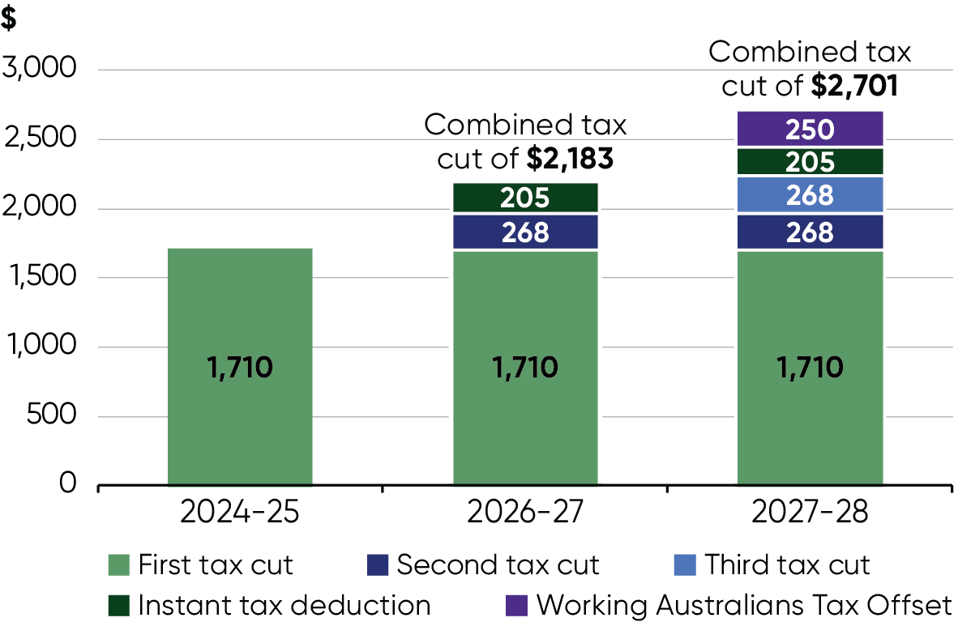
Note: The combined tax cut is compared to 2023–24 tax settings. The worker is assumed to have annual taxable income equal to annualised average weekly earnings of $81,245 (after incorporating an annual deduction for work-related expenses of $359). From 2026–27 onwards, the worker’s taxable income is further reduced by the instant tax deduction (providing a tax benefit of $205). From 2027–28, the worker is assumed to benefit from the full WATO. Tax payable is calculated accounting for basic tax rates and thresholds and the Medicare levy.

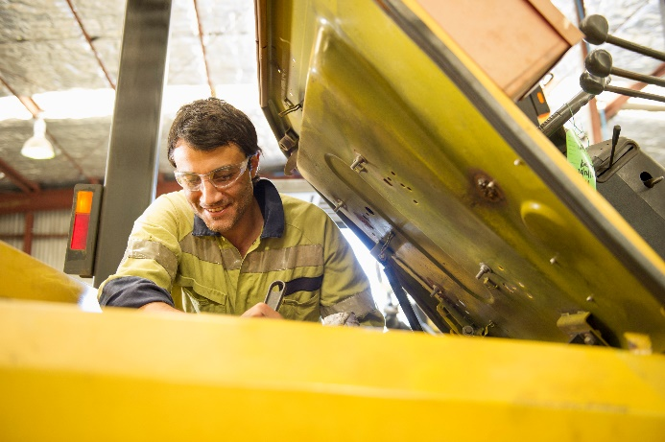
Dean is a mechanic and has taxable income of $70,000 per year, after claiming $300 in work-related expenses. He received a tax cut of $1,429 in both 2024–25 and 2025–26 from the first round of tax cuts, compared with the 2023–24 tax settings. When combined with the new $250 WATO and the two upcoming rounds of tax cuts, his saving will grow to $2,125 per year from 2027–28. Dean will further reduce his tax by $224 per year by claiming the $1,000 instant tax deduction.

Helping with the cost of fuel
$2.9 billion to more than halve the fuel excise

Taking the sting out of fuel prices
The Government has delivered a $2.9 billion package to more than halve the fuel excise and reduce the heavy vehicle road user charge to zero for three months from 1 April 2026. Excise on petrol and diesel has fallen from 52.6 to 20.6 cents per litre. The states and territories will provide the Commonwealth up to $400 million to support the fuel excise reduction.
These changes ease cost-of-living pressures on households and help the road transport industry continue its vital work.

A fair go for consumers and small businesses
The Government has directed the ACCC to undertake weekly reporting on retail fuel prices. We have also doubled the maximum penalties for major breaches of competition and consumer laws to $100 million and are providing more resourcing for enforcement.
The Government is also introducing penalties for breaches of the Oil Code of Conduct.

Support for businesses
The ATO is streamlining access to temporary relief from tax obligations for eligible businesses until 30 June 2026. This includes more generous payment plans, remission of interest and penalties, support in varying pay as you go (PAYG) instalments where there has been a reduction in taxable income, and a new dedicated channel for businesses to access relief.
Some compliance actions will also be limited across the worst affected industries, and debt collection actions may be paused where appropriate.

Anjali is a teacher and drives to work in her small petrol hatchback. On average, she needs to fill her 40-litre tank once a week. Under the changes, Anjali saves around $14 in excise and GST per tank and around $170 over the three month period.

More homes and a fair go for first home buyers
$2 billion for the Local Infrastructure Fund, supporting up to 65,000 homes

Helping more Australians own their own home
The Government is building on its Homes for Australia plan to make it easier for more Australians to buy a home. Since May 2022, we have helped more than a quarter of a million Australians achieve home ownership through the 5% Deposit Scheme.
The Government is building on these efforts in this Budget by reforming negative gearing and capital gains tax concessions to help level the playing field for first home buyers and support more Australians to realise the dream of home ownership.
These tax changes are estimated to support an additional 75,000 homeowners over the decade. The small impact on housing supply from these tax measures will be more than offset by measures that increase housing supply. Overall, this Budget will support more housing supply.

Building more homes
The Government is establishing a new $2 billion Local Infrastructure Fund to help local governments and state utilities build essential infrastructure to support new housing – including by connecting essential services such as water, power, sewerage and roads. This funding will support up to 65,000 homes over the decade and brings the Government's total investment in housing-enabling infrastructure to $6.3 billion.
The Local Infrastructure Fund will be available in states and territories that commit to pro-housing supply reforms. This includes speeding up and simplifying approvals, making more land available and ready for new homes and simplifying the National Construction Code.

Banning foreign investors from buying existing homes
The Government is extending the ban on foreign buyers purchasing established homes until mid-2029. The ban means Australians will be able to buy homes that would have otherwise been bought by foreign investors, while maintaining incentives to invest in additional housing supply.

Making renting fairer and more affordable
The Government is continuing to work with states and territories to harmonise and strengthen renters’ rights across Australia through A Better Deal for Renters. As a result, most states have now banned ‘no grounds’ evictions, limited rent increases to once per year and set minimum rental standards.
The Government has also delivered the first back-to-back increases in Commonwealth Rent Assistance (CRA) in more than 30 years and continues to support over 1.4 million renters through CRA. Combined with indexation, maximum rates of CRA have increased by over 50 per cent since March 2022.

Securing more housing for Australians doing it tough
The Government is investing $59.4 million to help Community Housing Providers provide social housing for over 4,000 young people aged 16–24 who are at risk of or experiencing homelessness. This will help young Australians avoid homelessness through stable housing, setting them up for a better future.
The Government is continuing to roll out an ambitious social and affordable housing agenda, delivering 55,000 social and affordable homes across Australia. This Budget also releases a further $100 million from the Housing Australia Future Fund to improve the quality of housing for First Nations Australians in remote communities.

More affordable and accessible healthcare

Cheaper medicines
The Government has cut the cost of medicines to their lowest levels in over 20 years, reducing the maximum general co-payment under the Pharmaceutical Benefits Scheme (PBS) to $25 and freezing the concessional rate at $7.70 until 2030.
The Government is investing $5.9 billion in this Budget to list new medicines on the PBS, including treatments for cystic fibrosis, chronic kidney disease, various cancers and more. This includes permanently cutting the cost of COVID-19 oral antiviral medicines. Since 1 July 2022, the Government has funded 437 new or amended PBS medicines.
The Government is also providing $449.3 million to list the respiratory syncytial virus (RSV) vaccine Arexvy® for eligible older Australians on the National Immunisation Program to protect against respiratory infection caused by RSV.

Record funding for public hospitals
The Government is delivering a landmark $25 billion in additional funding for state and territory hospitals to reach a record $220.3 billion over five years. The renewed National Health Reform Agreement will ensure Australians receive safe and high-quality care.

Investing in Medicare Urgent Care Clinics
The Government is investing $1.8 billion and $580.2 million each year ongoing to secure the future of Australia's 137 Medicare Urgent Care Clinics – making them a permanent feature of Australia's health system. These clinics have delivered almost three million free visits, and by July 2026 four in five Australians will have a clinic located within a 20-minute drive of where they live.
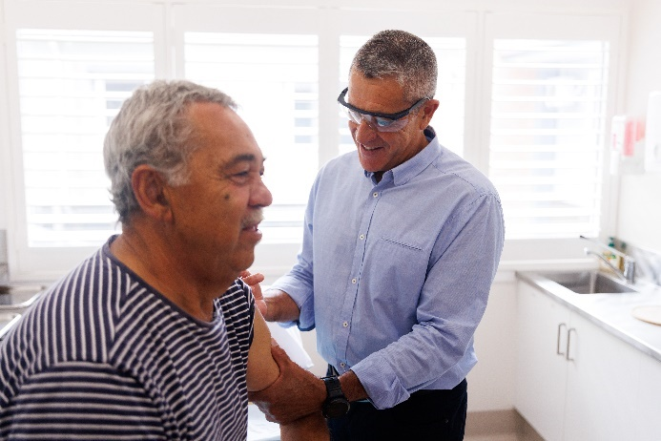
Ken has severe asthma. Now that the vaccine for RSV is available to eligible older Australians through the National Immunisation Program, he can receive this important vaccination for free when he goes to the GP, an immunisation clinic or a participating pharmacy. This will help protect him, his family and his community from severe disease caused by this common illness.

Growing wages

Increases to minimum and award wages
The Government has backed wage growth for low-paid workers in each of the last four Annual Wage Reviews. Across these reviews, the National Minimum Wage increased by over $9,120 per year.
For the current 2026 Annual Wage Review, the Government has recommended the Fair Work Commission (FWC) award an economically sustainable real wage increase to Australia’s award workers. Women and younger people are more likely to be reliant on minimum and award wages.

Addressing the gender pay gap
The Government is supporting a historic review to address gender pay gaps. The FWC has found historical gender undervaluation occurred in five priority modern awards across female dominated sectors like child care, health (including First Nations workers) and social services. Changes to classifications and minimum pay rates for some awards have already started to take effect, such as the Children's Services Award. Further decisions are due on the Health Professionals and Support Services, and the Social, Community, Home Care and Disability Services Industry Awards.

Adult age, adult wage
The FWC's decision to phase out junior pay rates will help ensure young workers get fair and decent wages. Junior award rates of pay will be phased out for retail, fast food and pharmacy workers aged 18 to 20.

Responding to changing fuel costs
The Government has amended the Fair Work Act 2009 to allow the FWC to make orders to deal with rising fuel prices. On 21 April 2026, an order came into effect to help road transport businesses and workers, by regularly adjusting the rates they are paid. This will help the many owner-drivers and small transport operators recover costs from higher fuel prices.

Making our economy more productive
$10.2 billion a year reduction in regulatory burden
$13 billion increase to long-run annual GDP through building a Single National Market
Unlocking $400 million more R&D investment by young firms each year
14 new legislative reform proposals to reduce red tape in the financial sector
13 actions by financial regulators to streamline data collections and reduce costs
Removing 497 more nuisance tariffs to streamline trade and reduce compliance costs
Implementing 'tell us once' reforms that simplify interactions with government
$654.3 million to expand use of Digital ID to reduce the sharing and storage of personal data
More than $500 million to accelerate and streamline environmental approvals
New 30 day target for decisions on all low-risk foreign investment applications
Savings of up to $1,600 a year for small businesses and tradies by providing free access to standards referenced in legislation
Reserving 20 per cent of gas exports for Australians
Accelerating heavy vehicle reforms to increase transport productivity and support the uptake of zero emissions heavy vehicles
Providing $1.5 billion to support research and Australia’s scientific institutions
Better coordinating our more than $39 billion investment in R&D over the next four years through the new National Resilience and Science Council

Delivering on our productivity agenda
Around 1,000 tariffs abolished, saving businesses over $157 million in compliance costs each year
Higher productivity makes our economy more adaptable and resilient, spurs business investment and builds a more prosperous future. This Budget advances the reform directions set by the Treasurer’s Economic Reform Roundtable, delivering a significant package of practical reforms that will meaningfully boost productivity growth. Together, they will make it easier to build, easier to do business and easier to invest and innovate.

Incentivising investment and innovation
This Budget delivers landmark tax reforms that will encourage investment and innovation, including loss refundability, a permanent $20,000 instant asset write-off and expanded tax incentives for venture capital. Reforms to the Research and Development (R&D) Tax Incentive will unlock $400 million per year in additional R&D by young firms.
The annual superannuation performance test plays a key role in protecting members from persistent underperformance. The Government will strengthen the test to help reduce unintended barriers to investment that supports member outcomes.
The Government is taking a more coordinated approach to directing public funds to priority sectors of the economy. A stronger Investor Council will support the Investor Front Door to prioritise investment proposals and identify opportunities for coordinated public financing; with up to $125 billion being deployed by the Government’s specialist investment vehicles.

Reducing red tape
The Government is reducing financial sector compliance costs by $780 million a year by progressing 14 legislative reforms, including increasing company reporting thresholds. Financial regulators are also taking 13 actions to streamline their data collections to reduce compliance costs.
We will regularly introduce regulatory reform bills to improve and modernise regulation, building on the 60 measures legislated in 2025.

Removing barriers to trade
The Government is abolishing another 497 nuisance tariffs from 1 July 2026, bringing the total abolished to around 1,000 and saving businesses $157 million a year in compliance costs. The Government will also consult on abolishing additional tariffs to further cut costs for Australian businesses.
We are simplifying trade through the landmark Australia-EU Free Trade Agreement, expanding the Australian Trusted Trader program and streamlining biosecurity border processes.

Building a Single National Market
The Government will work with states on reforms to payroll tax administration, in addition to further improving labour mobility through national occupational licensing, allowing health practitioners to work to their full scope of practice and a national approach to screening care workers.

Making it easier to engage with Government
The Government is implementing a ‘tell-us-once’ approach and investing $654.3 million to expand use of Digital ID to safely verify identity, reduce data storage and improve access to government services online. A further $62 million is being invested into the Consumer Data Right, including finding new ways for customers to use their own data to save money and get better services.

Accelerating approvals
The Government is accelerating environmental, low-risk foreign investment, resources and telecommunications approvals to make it easier to launch new projects. It is delivering stronger environmental outcomes through more than $500 million to implement approval reforms that deploy AI, cut duplication with states and fund more bioregional plans and strategic assessments. It is also strengthening the Investor Front Door to help nationally significant projects.

Building more homes
The Government is funding last-mile infrastructure to unlock up to 65,000 homes in states and territories that drive productivity in the housing sector, including by speeding up approvals, making more land ready for new homes and modernising the National Construction Code.
The Government is also taking action to simplify building regulations and make it easier to build by providing free access to all standards referenced in Australian legislation, saving small businesses and tradies up to $1,600 per year, and removing barriers to using modern methods of housing construction.

Modernising energy markets
The Government is working with states and territories to pursue the most significant reforms to our energy market since the 1990s. These upgrades will make our system more productive and competitive and for the first time allow household solar and battery systems to directly participate in the market. The changes will level the playing field and ensure larger companies face retail competition while unlocking investment in renewables through clear long-term pricing signals.
We are introducing a domestic gas reservation from 1 July 2027 to ensure Australian gas stays on our shores, requiring LNG producers to reserve 20 per cent of their export volumes for Australian users to reduce pressure on prices.

Better recognising skills
The Government is investing $85.2 million to accelerate skills assessments for migrant trades workers and to accelerate occupational licensing, making it faster for them to enter the workforce. The Government is also reforming the permanent migration points test to select better educated, higher-skilled and younger migrants.
University students with relevant TAFE qualifications will benefit from quicker degrees through a National Credit Recognition Framework.

Unlocking the data and AI opportunity
The Government is providing up to $70 million for ‘AI Accelerator’ grants to boost AI development. It is also advancing use of AI in government, including to accelerate environmental and medicine approvals and make the National Construction Code easier to use.

Investing in science and innovation
The Government is investing $1.5 billion in our research and scientific institutions including CSIRO, the National Measurement Institute and the Square Kilometre Array. To maximise value from its innovation investment, the Government is establishing the National Resilience and Science Council to coordinate and align public innovation investments. The Government has also provisioned $508.5 million to increase disbursements for medical research from the Medical Research Future Fund.

Reducing the regulatory burden
The Government’s productivity reforms will reduce regulatory burden by $10.2 billion each year, boost long-run GDP by around $13 billion a year, and progress 13 of the 17 reform areas identified by the Productivity Commission’s five pillar inquiries.
Key regulatory burden reductions
Reform | Estimated regulatory burden reduction ($m/year)^
Accelerating approvals – Streamlining Environment Protection and Biodiversity Conservation Act 1999 (EPBC Act) assessments | 3,045
Building more homes – Reforms to build more homes | 3,000
Building a Single National Market – National Competition Policy reforms underway with states and territories | 2,050
Reducing red tape – Financial sector reform and Council of Financial Regulators’ Better Regulation Roadmap | 961
Reducing red tape – Simplifying the tax system | 415
Unlocking the data and AI opportunity – Using AI to evaluate the suitability of medicines | 340
Making it easier to engage with Government – ‘Tell-us-once’ reforms | 190
Removing barriers to trade – Abolishing 497 nuisance tariffs | 127
Other items | 81
Total | 10,209
^Estimates represent reductions in the administrative, substantive, and delay costs once the policy has been fully implemented. For further details on how these numbers have been estimated, please see the Budget 2026–27 Whole-of-Government Regulatory Reform Agenda Factsheet.

Tax reform for workers, businesses and future generations
Delivering the most significant transformation of the tax system in more than a quarter of a century
Cutting taxes five times, helping workers keep more of what they earn
A new $250 Working Australians Tax Offset and a $1,000 instant tax deduction, on top of three legislated rounds of tax cuts
Providing an Australian worker on average earnings a combined benefit of up to $2,816 per year from the Government's five tax cuts
Supporting an additional 75,000 Australians to become homeowners by making the tax arrangements for housing investment fairer
More closely aligning the tax rates for trusts with the rates paid by workers who earn a living from wages
Over $3.5 billion in new measures that lower taxes for businesses to reward investment and innovation
Supporting investment and resilience for 85,000 businesses by permanently reintroducing loss carry back
Backing innovation with loss refundability for start-ups, expanding incentives for venture capital and better targeting the Research and Development Tax Incentive
Making the $20,000 instant asset write-off permanent for small business
Making the tax system simpler and more sustainable, with a simplification package that delivers a combined annual compliance savings of over $500 million for workers and businesses

A better tax system for workers, first home buyers and future generations
13 million+ workers benefit from the Working Australians Tax Offset from 2027–28
75,000 additional homeowners supported by the tax reforms
The Government is reforming the tax system to help more Australians realise the dream of home ownership, better encourage productive investment and help fund a new $250 tax offset for workers.

Cutting taxes for working Australians
The Government is introducing a $250 Working Australians Tax Offset from 2027–28, providing an ongoing annual tax cut for over 13 million Australian workers. This is on top of the three tax cuts the Government has already legislated and the $1,000 instant tax deduction.
For an Australian worker on average earnings, the combined benefit of the Government’s five tax cuts could be up to $2,816 per year, helping every Australian worker keep more of what they earn.

Capital gains tax
While supply is an important driver of housing affordability, tax also plays a role.
The Government will replace the 50 per cent Capital Gains Tax (CGT) discount with a discount based on inflation and introduce a minimum 30 per cent tax on gains from 1 July 2027.
This reform means that investors will only pay tax on their real capital gain, restoring the original intent of the CGT arrangements. It will support productive investment in assets such as higher density housing and shares while reducing incentives for debt-financed investment in some areas, like existing detached housing. It means investors with lower gains will pay less tax, while those with gains well above inflation will pay more.
The CGT reforms will only apply to gains arising after 1 July 2027. Investors in new builds will be able to choose the 50 per cent CGT discount or the new arrangements.

Negative gearing
Negative gearing compounds the impact of the CGT discount on housing affordability. 83 per cent of new investor loans in 2025 were for existing property, not new housing.
The Government will limit negative gearing to new builds from 1 July 2027, to focus tax support on new supply.
Existing arrangements will remain unchanged for all properties held before Budget night, and investors who buy new builds will still be able to deduct losses from other income.
Investors who buy established housing after Budget night will still be able to deduct losses against residential property income. They will be able to carry forward unused losses to future years but won't be able to deduct them against other income like wages.

Helping more Australians own their own home
The CGT discount and negative gearing reforms will help improve affordability for first home buyers and support around 75,000 additional owner-occupiers over the next decade. This reflects an increase in the home ownership share of around 1 percentage point, equivalent to reversing around ten years of declines.
The impact on housing supply from these tax measures will be more than offset by measures that increase housing supply.

Fairer tax arrangements for discretionary trusts
The Government will introduce a minimum tax of 30 per cent on discretionary trusts from 1 July 2028 with some exceptions. This will create more equal treatment between workers who earn a living from wages and people with income from trusts, and help fund a $250 tax offset for every working Australian taxpayer.
There are many legitimate reasons to use discretionary trusts, but the number has doubled over the past 20 years, faster than the growth in the number of companies, making the system unsustainable.
Rollover relief will be provided for three years from 1 July 2027 to assist small businesses and others that wish to restructure.

A better tax system for businesses
$400 million increase in R&D by young firms per year
20% increase in R&D delivered for each dollar of tax offset

Boosting resilience and dynamism
The Government is reintroducing loss carry back to support business risk taking and resilience. From 2026–27, eligible companies who make a loss in the current income year will be able to use that loss to get a refund against tax paid in the prior two income years. This will benefit up to 85,000 companies, mostly small businesses.
The Government is also introducing loss refundability to support new start-up businesses. From 2028–‍29, small start-ups in their first two years of operation will be able to get a refund for tax losses, up to the value of fringe benefits tax and withholding tax paid on employee wages. This will benefit up to 25,000 young companies each year, providing valuable cash flow support.
The Government is also improving cash flow for small businesses by permanently extending the $20,000 instant asset write-off (IAWO) from 1 July 2026. Small businesses with turnover up to $10 million will be able to immediately deduct eligible assets costing less than $20,000, helping them to make their investment decisions with confidence. This is estimated to improve cash flow for small businesses by around $890 million over the next five years.
These reforms form part of the Government's strategy to improve economic resilience, support productivity and promote employment.

How small businesses can benefit from IAWO and loss carry back

Dining Co runs a local restaurant with $1 million in turnover. It generated $50,000 in taxable profits and paid $12,500 tax in 2025–26 (at the 25% tax rate).
In 2026–27, Dining Co decides to supply ready-cooked meals to local supermarkets. It purchases new equipment for a total of $65,000, with each piece costing less than $20,000. Due to the IAWO, these items can be immediately deducted.
Without these new investments, Dining Co would have reported a $50,000 profit in 2026–‍27. However, with the IAWO deductions, it reports a $15,000 tax loss and pays no tax.
Further, Dining Co will now be able to carry back that tax loss to the previous year's tax paid, generating a $3,750 tax refund ($15,000 x 25% tax rate). This provides timely cash flow to the company as it seeks to expand.

Expanding venture capital incentives
From 1 July 2027, the Government will expand venture capital tax incentives to align with modern company valuations. This will help to unlock patient capital for young, expanding firms that find it hard to access traditional finance.
Changes to the Early-Stage Venture Capital Limited Partnership (ESVCLP) and Venture Capital Limited Partnership (VCLP) programs will support start-ups and high-growth businesses to unlock greater access to capital and industry knowledge.
They will also provide investors, including superannuation funds, with greater flexibility to invest for longer periods, make larger contributions, and support more cutting-edge, forward-thinking new businesses.
Expanding venture capital incentives
Reform | Previous settings | New settings
VCLP cap on eligible investee business assets | $250 million | $480 million
ESVCLP cap on eligible investee business assets | $50 million | $80 million
ESVCLP cap on investee business assets where investment returns are fully tax exempt | $250 million | $420 million
ESVCLP maximum fund size | $200 million | $270 million

Better targeting the Research and Development Tax Incentives
The Government will better incentivise core R&D that benefits the broader economy, in response to recommendations of the Ambitious Australia Report. From 1 July 2028, the Government is:
- Increasing the offset for experimental core R&D by around 25 to 50 per cent and removing eligibility for expenditure that only supports R&D. The intensity threshold will reduce to 1.5 per cent, providing higher offsets to firms undertaking substantial core R&D.
- Providing greater support to young, fast-growing firms by increasing the turnover threshold for the higher, refundable offset to $50 million. Refundability will be limited to firms operating less than ten years, with older firms eligible for an equivalent, non-refundable offset.
- Increasing the maximum expenditure cap to $200 million, encouraging more R&D onshore.
- Improving assurance by increasing the minimum expenditure threshold to $50,000. R&D below this must be undertaken with a Research Service Provider or Cooperative Research Centre.

A simpler and more sustainable tax system
$205 average saving for 6.2 million workers for 2026–27 from the instant tax deduction
$32 million saved per year in compliance costs by small businesses through the IAWO
2 million businesses can choose dynamic monthly instalments
The Government is making Australia's tax system simpler and more sustainable by making tax easier to manage for businesses and individuals.

Making tax easier for workers and small businesses
Making the tax system simpler means less time and money spent on tax time and compliance. The Government’s reforms will support productivity by reducing compliance costs for workers and businesses, better leveraging business software and improving business cash flows.
From 2026–27, a new instant tax deduction of up to $1,000 will simplify work-related expense deductions. This will deliver 6.2 million workers an average tax benefit of $205 for 2026–27 and reduce compliance costs by around $380 million a year.
The $20,000 instant asset write-off for small business will be made permanent, simplifying tax obligations, improving cash flow and saving small businesses around $32 million per year in compliance costs.
The Government is also boosting business cash flow by making it easier for businesses to change their pay as you go (PAYG) instalments when business conditions change, by:
- providing businesses with flexibility to opt in to monthly PAYG instalments from 1 July 2027, and
- expanding access to the ATO's dynamic instalments pilot using business software to more accurately calculate PAYG instalments.
The Government will work with states on reforms to payroll tax administration.
These initiatives build on the ATO's commitments following the Economic Reform Roundtable to reduce tax compliance costs by using taxpayers' business systems to capture and pre-fill information to automate reporting and payment of tax.

More sustainable settings to support take-up of electric cars
Since the introduction of the electric car discount in 2022, electric car sales have increased strongly and the market has matured with an increased choice of electric cars and wider range of models and price points. As a result, more Australians are driving electric cars and accessing the benefits.
The Government will transition the arrangements to support electric cars to a permanent 25 per cent fringe benefits tax (FBT) discount, for eligible electric cars over $75,000 from 1 April 2027 and for all eligible electric cars from 1 April 2029. Electric cars costing up to $75,000 will continue to receive a full FBT exemption provided the fringe benefit arrangement commences before 1 April 2029.
These new arrangements continue targeted support for the shift to electric cars, while ensuring the sustainability of the system in the long term, and reflect the recommendations of the statutory review of the electric car discount policy.

Strengthening care and broadening opportunity
Securing the NDIS for future generations by restoring it to its original intent of supporting people with permanent and significant disability
$2 billion to establish Thriving Kids, to be matched by states and territories
$200 million for the Inclusive Communities Fund to support community organisations to provide group based social support to NDIS participants
$3.7 billion to deliver more beds, more packages and better care for older Australians
An additional $25 billion for public hospitals, which includes funding to improve health outcomes and strengthen First Nations health
$1.8 billion to support ongoing investment in 137 Medicare Urgent Care Clinics
More than four in five GP services bulk billed, supported by over 3,700 fully bulk billing practices
Investing a further $2.2 billion into Services Australia to ensure millions of Australians continue to receive safe, secure and reliable services quickly and easily
$299 million to support an additional 3,000 jobs in remote communities
$48.3 million to support Aboriginal Hostels Ltd deliver critical short-term accommodation services
$182.6 million to make the Child Support Scheme safer and more effective by addressing financial abuse and non-compliance
Over 87,500 additional families eligible for at least 72 hours of subsidised care through the Child Care Subsidy because of the 3 Day Guarantee
$218.3 million to deliver Our Ways – Strong Ways – Our Voices, Australia's first standalone plan to end violence against Aboriginal and Torres Strait Islander women and children

Securing the NDIS for future generations

Returning the NDIS to its original intent
The NDIS was established to support people with permanent and significant disability. The reforms in this Budget will protect that original intent for current and future participants. The Government will implement reforms across four pillars to secure the future of the NDIS.
- To ensure quality services and supports that meet the needs of participants, the Government will commission plan management and support coordination, and consult on a commissioning approach for home and living supports for Supported Independent Living participants so they receive the best supports and address provider viability challenges.
- To set clearer eligibility requirements, the Government will put standardised, evidence-based assessments of functional capacity at the core of determining access to the NDIS.
- To slow cost increases, the Government will tighten criteria around plan reassessments and strengthen guidance about what are reasonable and necessary supports. Budgets for social, civic and community participation and capacity building daily activities will be reset, and New Framework Planning will deliver more equitable, consistent and sustainable participant plans from April 2027.
- To fight fraud and stop rorts, the Government will increase oversight of providers and payments, strengthen the National Disability Insurance Agency’s investigative and enforcement capabilities, and introduce new regulatory controls to protect participants and the NDIS from exploitation.
The Government is also providing $2 billion to establish the Thriving Kids program as part of the $5 billion Foundational Supports commitment to be matched by the states. This will rebuild capability in the broader system of community supports for people with disability.
These reforms are expected to save a total of $37.8 billion over the next four years. The NDIS will continue to grow each year and remain Australia’s largest social program outside of the Age Pension. It will continue to be the centrepiece of a comprehensive suite of supports for people with disability.

Better care for older Australians
This Government is investing $3.7 billion to deliver more beds, more packages and better care for older Australians to ensure they get the support they deserve.

More aged care beds and Support at Home packages
The Government is investing $1.7 billion to incentivise construction of up to 5,000 aged care beds a year and protect equity of access for those less well off.
This investment includes $606.5 million to introduce new capital subsidies for aged care providers who build or expand residential accommodation, deliver up to 20 additional Specialist Dementia Care units and expand the Hospital to Aged Care Dementia Support program from 11 to 20 locations nationally.
The Government is also provisioning $1.1 billion for future spending to increase and restructure the Accommodation Supplement and introduce an additional payment for homes with more than 60 per cent low-means residents.
An additional $565.1 million will improve sector quality, safety and viability. This builds on the Government's first term measures to improve the quality of residential aged care, including by increasing minutes of care delivered to older Australians and strengthening regulatory oversight.
The Government is providing $389.8 million to accelerate the release of Support at Home packages and make the program fairer and more affordable. This includes improvements to assessments, hardship applications and the end-of-life pathway. This investment will continue the Government's work to set the system up for generations to come.

Quality, affordable personal care for older Australians
The Government is committing $1 billion to fully subsidise and remove co-contributions for personal care services such as showering through the Support at Home program. These changes build on the Government’s landmark aged care reforms that have codified the rights of older Australians in law and established a system to deliver safe, dignified and high-quality care for an ageing population.

Strengthening Medicare
3,761 Medicare bulk billing practices

Record funding for public hospitals
The Government is delivering $25 billion in additional funding for public hospitals, to reach a record $220.3 billion over five years. The renewed National Health Reform Agreement will ensure Australians receive safe and high-quality care. Reforms will also better meet the needs of First Nations people with a dedicated funding schedule.

Investing in Medicare Urgent Care Clinics
This Budget provides $1.8 billion to secure the future of Medicare Urgent Care Clinics as permanent features of Australia's health system. This builds on previous investments to expand the total network to 137 clinics across Australia.
The network has delivered almost three million free visits nationwide. By July 2026, four in five Australians will live within a 20-minute drive of their local Medicare Urgent Care Clinic.

More bulk billing
The Government has invested $11.4 billion to incentivise bulk billing, with a goal of ensuring nine out of ten GP services are bulk billed by 2030. Since the Government's recent bulk billing reforms commenced on 1 November 2025, 1,420 general practices across Australia that were previously mixed billing have become fully bulk billing. The national GP bulk billing rate has also risen to 81.4 per cent in the period between November 2025 and January 2026.
This Budget also provides an additional $25.3 million in targeted funding to lift bulk billing rates in the Central Coast, Newcastle, Lake Macquarie and Hunter regions.

Broadening opportunity and increasing equality
$299 million creating an additional 3,000 jobs in remote Australia

Investing in First Nations communities and Closing the Gap
The Government continues to work with First Nations communities to deliver Closing the Gap commitments. This Budget invests $1.2 billion, building on work already underway, including a 10-‍year, $4 billion joint investment to halve overcrowding in remote Northern Territory communities, and targeted investment in Indigenous Rangers programs, education, justice reinvestment, health, water and digital connectivity.

Jobs and economic empowerment
The Government is investing $299 million to double the successful Remote Jobs and Economic Development Program from 3,000 to 6,000 new jobs – delivering the dignity of work with decent pay and conditions in First Nations communities.

Easing the cost-of-living for remote communities
The Government has invested an additional $27.4 million to expand the Low-Cost Essentials Subsidy Scheme to all 225 remote stores around Australia, reducing prices for 30 essential grocery items. The Store Efficiency and Resilience Package is also being expanded to 75 more remote stores, with $32.7 million to increase supplies of groceries and essentials in preparation for seasonal weather events.

Investing in culturally-safe healthcare
The Government is continuing to invest in improving health infrastructure across Aboriginal Community-Controlled Health Services with $144.1 million to expand on the more than 100 projects already delivered or underway.
The Government is also supporting Birthing on Country with $44.4 million for culturally-safe maternal care for 1,100 mothers, and providing $18.9 million to expand access to culturally-safe crisis care through 13YARN.
The Government's investment in public hospitals also includes almost $250 million in dedicated funding for new, co-designed programs to improve First Nations health outcomes, with $200 million matched by states and territories.

Improving education outcomes
The Government is investing $113 million to improve education outcomes, including extending the Clontarf Foundation's young men's program and the Indigenous Boarding Provider grants program.

Continuing to support veterans and their families
This Budget provides a further $583.4 million to implement recommendations from the Royal Commission into Defence and Veteran Suicide, and $169.7 million for allied health services for veterans.

Supporting women and advancing gender equality
The Government is improving the lives of Australian women by putting gender equality at the centre of decision making. The gender pay gap is at an historic low and women’s workforce participation reached record highs in 2025.

A safer and more effective Child Support Scheme
The Government is investing $182.6 million to make the Child Support Scheme safer so children get the financial support they need and women are protected from conflict and abuse.

Supporting families and children
The 3 Day Guarantee entitles eligible families to three days of subsidised child care per week. From July, government-funded Paid Parental Leave will increase to a full six months. This Budget also provides $171.7 million for front line community services including through a new, simplified Children and Families Support program.

Better healthcare for women
This Budget will expand access to Keytruda®, a cervical cancer treatment, and support more long-acting reversible contraceptives, while continuing the work to achieve universal perinatal mental health screening.

Addressing violence against women, children and families
Since 2022, the Government has invested over $4.4 billion to deliver the National Plan to End Violence against Women and Children.
The Government is also investing $218.3 million to support delivery of Our Ways – Strong Ways – Our Voices, Australia's first standalone plan to end violence against Aboriginal and Torres Strait Islander women and children.

Building a resilient and secure Australia
Supporting jobs in critical industries, including by investing up to $1 billion in the transition of Boyne Island Aluminium Smelter to renewable energy
Strengthening critical minerals supply chains, including through delivering the Critical Minerals Strategic Reserve
A record additional $53 billion investment in Defence capabilities to increase self-reliance and resilience
Up to $15 billion of total investment in autonomous and uncrewed systems in the decade to 2035–36
Achieving better value for money through reforms to Defence's acquisition and sustainment practices and building Australia's defence industrial base
An initial $12 billion to establish the Henderson Defence Precinct as a world class centre of excellence for naval shipbuilding in Western Australia
$8.6 billion for nationally significant road and rail projects, including an additional $3.8 billion for Victoria's Suburban Rail Loop East
$841.7 million to build community infrastructure across Australia
$604.2 million to address hate speech, violent extremism and terrorism
Accepted all 13 recommendations of the Plan to Combat Antisemitism

Future Made in Australia

Supporting resilient metals production
The Government is capitalising on economic opportunities available through the net zero transition and working to ensure the continued success of our metals smelting capabilities into the future. This includes investing up to $1 billion in the Boyne Island Aluminium Smelter to secure its long-term, lower emissions and renewables powered operations, with funding matched by the Queensland Government and unlocking almost $7.5 billion in private investment.
The Government is partnering with state governments to support critical facilities that contribute to Australia's economic prosperity. This includes $222.6 million in further funding to support the administration and ongoing operations of the Whyalla Steelworks, as well as support for employees of the Liberty Bell Bay manganese smelter while work progresses to find new owners for both facilities.

Securing critical minerals supply chains
Growing Australia’s critical minerals industry will help create diverse, resilient and sustainable global supply chains. The Government has delivered on its commitment to establish a Critical Minerals Strategic Reserve. Future transactions under the Reserve will be led out of the Department of Industry, Science and Resources, in close partnership with Export Finance Australia. The Reserve will initially focus on antimony, gallium and rare earth elements which are crucial for clean energy and high-technology manufacturing, as well as advanced military equipment.
The Reserve will draw on $1 billion from the previously expanded $5 billion Critical Minerals Facility for transactions. The Government is also providing $150 million for selective stockpiling of minerals and $20.4 million to support the operation of the Reserve. To complement these efforts and ensure Australia can be a reliable supplier of critical minerals, the Government is providing $2.9 million to support delivery of Australia's international critical minerals commitments.

A record funding boost for defence

Bolstering Australia's defence capability
The Government is delivering the defence capabilities Australia needs to ensure a secure and prosperous future. The 2026 National Defence Strategy provides an additional $53 billion over the next ten years through direct Government investment and plans to leverage private sector funding. These investments will:
- increase the ADF’s ability to deter and respond to threats
- build a more self-reliant ADF for the future
- strengthen Australia’s sovereign defence industrial base
- increase coordination with our regional partners.
The 2026 Integrated Investment Program supports the National Defence Strategy by providing new and increased investment over the decade in high priority Defence capabilities, including:
- up to $130 billion on enhanced undersea warfare capabilities, supported by a fleet of conventionally-armed, nuclear-powered submarines
- up to $15 billion on autonomous and uncrewed systems, such as the Australian designed and built Ghost Bat and smaller, low-cost drones for deployment in large numbers
- up to $77 billion to deliver the enhanced surface combatant fleet and fleet support, including upgraded Japanese Mogami class frigates and Hunter class anti-submarine frigates
- an initial $12 billion to establish the Henderson Defence Precinct as a world class centre of excellence for naval shipbuilding and sustainment in Western Australia.

Building infrastructure for the future
$841.7 million to fund parks, community centres, sports and cultural facilities

Sustainable investment in transport infrastructure
The Government is maintaining a rolling infrastructure pipeline of more than $120 billion over ten years, with short-term profile adjustments in response to the effects of the Middle East conflict and potential constraints on capacity. This Budget includes over $8.6 billion for new and ongoing nationally significant projects.
Working in partnership with every state and territory, the Government's infrastructure pipeline will deliver the road and rail projects needed across our cities and communities. This includes $812.5 million in this Budget for the Bruce Highway upgrade between the Gateway Motorway and Dohles Rocks Road in Queensland, $45 million for safety improvements to the M1 in New South Wales, $500 million over ten years to continue the Active Transport Fund and $50 million to upgrade the Sydney to Canberra rail corridor.
It also includes $3.8 billion for Victoria's Suburban Rail Loop East, bringing the Government's total commitment to $6.0 billion. This landmark project will enable more transport and homes in the right places – cutting travel times, reducing congestion and reshaping how Melbourne grows.
In addition, the Government is making targeted freight and supply chain investments that will support the efficient movement of goods around the country. This includes $1.75 billion in equity for the Australian Rail Track Corporation to upgrade Australia's rail freight network.

Investing in communities
The Government is providing a further $841.7 million in community infrastructure, including through the Thriving Suburbs, Growing Regions and Stronger Communities programs. This will fund projects such as libraries, parks, community centres and sport and cultural facilities that enhance liveability, bolster social cohesion and enrich quality of life at a local level.

Support for disasters
The Government continues to support communities impacted by disasters. Funding for natural disaster relief is expected to increase by $2.5 billion.

Responding to the Bondi attack
$69 million for the Australian Federal Police's National Security Investigation teams
$80 million to respond to violent extremism, prevent youth radicalisation, and enhance capabilities to counter terrorism threats online
$70 million for the High Risk Terrorist Offender regime

Supporting victims and impacted communities
Together with the NSW Government, we have committed $21.7 million in Disaster Recovery Funding Arrangements to support the Bondi community. Support includes $2 million for Jewish community organisations, $1 million for legal services, up to $25,000 for local small businesses and $2.8 million for up to eight coordinators to support the local community and provide capacity building.
The Government has invested $42.9 million in mental health supports for the Jewish community and the broader Bondi community, including an interim Medicare Mental Health Centre in Bondi, which is providing free, walk-in mental health support.

Countering hate speech, terrorism and violent extremism
The Government is addressing hate speech, violent extremism and terrorism, committing $604.2 million to initiatives in response to the antisemitic Bondi terrorist attack. This includes $36.1 million for stronger hate crime and firearms laws, and continued work to progress the National Gun Buyback Scheme through National Cabinet. The Government is providing more funding to disrupt politically and ideologically motivated violence and hate crimes.

Support for Jewish Australians
The Government accepted all recommendations relevant to the Commonwealth from the Interim Report of the Royal Commission on Antisemitism and Social Cohesion and has committed to working with states and territories on a nationally consistent approach to implementing all 14 recommendations.
The Government adopted the Special Envoy to Combat Antisemitism’s Plan to Combat Antisemitism and is implementing the 13 recommendations in consultation with the Jewish Australian community and the Special Envoy.
The Government is also providing $46.7 million in financial support to the wider Jewish community, including for security and infrastructure upgrades and grant opportunities to support priority projects, including for a Chabad of Bondi project.

Appendices

Appendix A: Budget aggregates
Estimates
Cash estimates | Estimates  2025–26 | Estimates  2026–27 | Estimates  2027–28 | Estimates  2028–29 | Estimates  2029–30 | Estimates  Total^{(a)}
Underlying cash balance $ bn | -28.3 | -31.5 | -31.0 | -34.4 | -25.3 | -150.5
Underlying cash balance Per cent of GDP | -1.0 | -1.0 | -1.0 | -1.0 | -0.7
Receipts  $ bn | 759.8 | 798.1 | 822.9 | 848.4 | 894.8 | 4,123.9
Receipts  Per cent of GDP | 25.6 | 25.8 | 25.9 | 25.4 | 25.5
Payments  $ bn | 788.1 | 829.6 | 853.9 | 882.8 | 920.1 | 4,274.4
Payments  Per cent of GDP | 26.6 | 26.8 | 26.8 | 26.5 | 26.2
Estimates
Balance sheet estimates | Estimates  2025–26 | Estimates  2026–27 | Estimates  2027–28 | Estimates  2028–29 | Estimates  2029–30 | Estimates  Total^{(a)}
Gross debt^{(b)}  $ bn | 982.0 | 1,051.0 | 1,120.0 | 1,193.0 | 1,249.0
Gross debt^{(b)} Per cent of GDP | 33.1 | 34.0 | 35.2 | 35.8 | 35.6
Net debt^{(c)}  $ bn | 556.0 | 616.6 | 668.8 | 725.5 | 767.8
Net debt^{(c)}  Per cent of GDP | 18.8 | 19.9 | 21.0 | 21.8 | 21.9
Estimates
Accrual estimates | Estimates  2025–26 | Estimates  2026–27 | Estimates  2027–28 | Estimates  2028–29 | Estimates  2029–30 | Estimates  Total^{(a)}
Revenue  $ bn | 773.1 | 815.3 | 836.3 | 863.5 | 910.1 | 4,198.3
Revenue  Per cent of GDP | 26.1 | 26.3 | 26.3 | 25.9 | 26.0
Expenses  $ bn | 812.1 | 833.3 | 863.7 | 896.1 | 933.7 | 4,338.8
Expenses  Per cent of GDP | 27.4 | 26.9 | 27.1 | 26.9 | 26.6
Net operating balance  $ bn | -39.0 | -17.9 | -27.4 | -32.6 | -23.6 | -140.5
Net operating balance Per cent of GDP | -1.3 | -0.6 | -0.9 | -1.0 | -0.7
Net capital investment $ bn | 11.2 | 12.0 | 10.2 | 10.2 | 9.3 | 52.9
Net capital investment Per cent of GDP | 0.4 | 0.4 | 0.3 | 0.3 | 0.3
Estimates (continued)
Accrual estimates | Estimates  2025–26 | Estimates  2026–27 | Estimates  2027–28 | Estimates  2028–29 | Estimates  2029–30 | Estimates  Total^{(a)}
Fiscal balance  $ bn | -50.1 | -29.9 | -37.6 | -42.8 | -32.9 | -193.3
Fiscal balance Per cent of GDP | -1.7 | -1.0 | -1.2 | -1.3 | -0.9
Fiscal balance Memorandum
Fiscal balance Headline cash balance | -47.9 | -64.1 | -54.3 | -57.2 | -41.0 | -264.5
- Total is equal to the sum of amounts from 2025–26 to 2029–30.
- Gross debt measures the face value of Australian Government Securities (AGS) on issue at the end of the financial year.
- Net debt is the sum of interest bearing liabilities (which includes AGS on issue measured at market value) less the sum of selected financial assets (cash and deposits, advances paid and investments, loans and placements) as at the end of the financial year.

Appendix B: Revenue and spending
Total revenue for 2026–27 is expected to be $815.3 billion. Total expenses are expected to be $833.3 billion.
Where revenue comes from (2026–27)
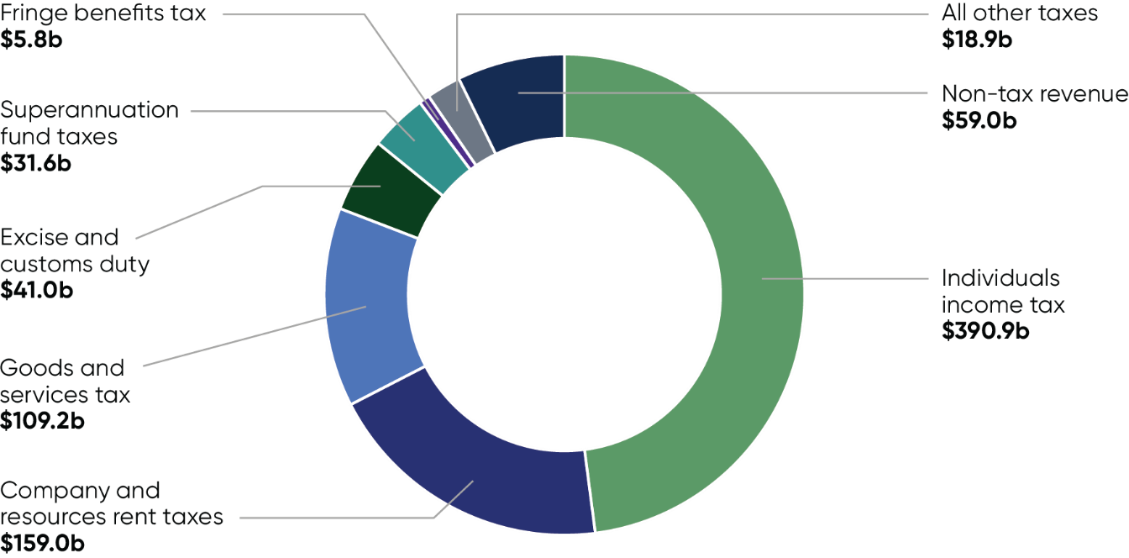

Where government spending is directed (2026–27)
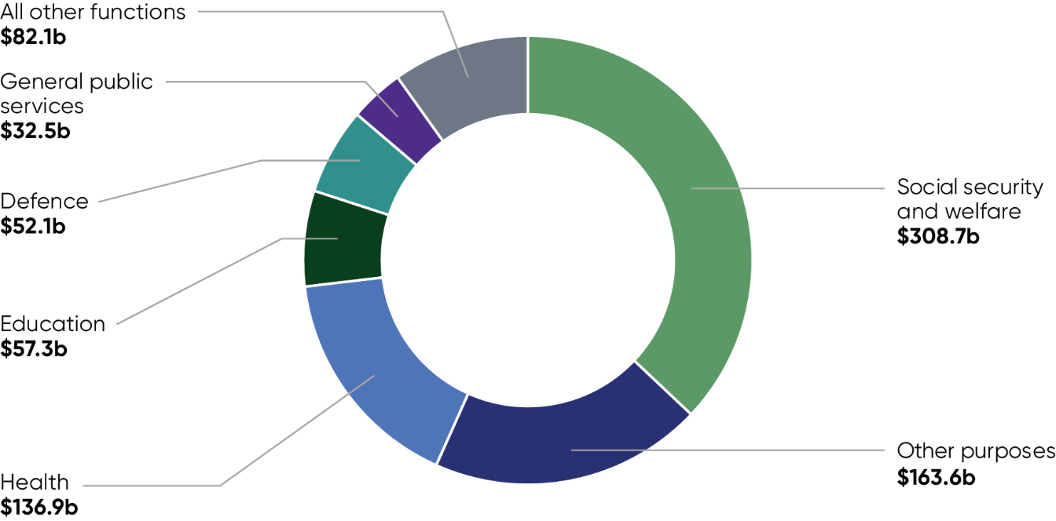

Appendix C: Major initiatives
This table summarises the major initiatives in the 2026–27 Budget and their impact on the underlying cash balance. More comprehensive information is provided in Budget Paper No.2, Budget Measures 2026–27.
Major Initiatives
Initiatives^{(a)} | 2025–26 ($m) | 2026–27 ($m) | 2027–28 ($m) | 2028–29 ($m) | 2029–30 ($m) | Total  ($m)
National Health Reform Agreement - hospital funding and Commonwealth investment in the public hospital system | - | -3,456.8 | -4,008.7 | -4,862.2 | -5,799.1 | -18,126.8
2026 National Defence Strategy and Integrated Investment Program | -30.0 | -2,164.7 | -2,616.0 | -1,318.1 | -704.6 | -6,833.4
Tax Reform – cutting taxes with a Working Australians Tax Offset^{(b)} | - | -1.5 | -6.0 | -3,021.5 | -3,361.0 | -6,390.0
Pharmaceutical Benefits Scheme New and Amended Listings^{(c)} | -457.4 | -1,432.4 | -1,353.6 | -1,284.9 | -1,354.8 | -5,883.1
Tax Reform – loss refundability reforms for businesses and start‑ups^{(b)} | - | -8.7 | -911.0 | -733.0 | -1,075.5 | -2,728.2
Taking Pressure off Australians - Temporary reduction of fuel excise and heavy vehicle road user charge^{(b)} | -3,020.0 | 475.0 | - | - | - | -2,545.0
Services Australia – additional resourcing^{(b) (c)} | -1.0 | -1,109.4 | -1,004.2 | -3.7 | 0.2 | -2,118.1
Boosting Home Ownership | - | -262.0 | -523.6 | -614.0 | -652.1 | -2,051.7
Strengthening Medicare | -15.1 | -655.7 | -536.7 | -347.0 | -313.2 | -1,867.7
Thriving Kids | - | -427.4 | -436.0 | -396.9 | -368.1 | -1,628.4
Boosting productivity – better selecting migrants and recognising their skills^{(b)} | - | -114.8 | -322.8 | -508.4 | -662.1 | -1,608.1
Improving Access to Home Care | - | -408.6 | -296.5 | -327.9 | -361.5 | -1,394.5
Building a Better Future through Considered Infrastructure Investment^{(c)} | - | 1,569.8 | 817.7 | -1,286.4 | -2,067.8 | -966.7
Tax Reform – making tax simpler for businesses^{(b)} | - | -11.4 | -323.5 | -361.5 | -135.9 | -832.2
Community Infrastructure^{(b)} | 113.0 | -60.4 | -170.5 | -306.4 | -303.8 | -728.1
Boosting Productivity – Digital ID | - | -157.9 | -166.0 | -163.9 | -166.6 | -654.3
Residential Aged Care Supply and Equity of Access | - | -68.8 | -119.3 | -179.6 | -238.9 | -606.5
Enhancing Defence Cooperation in the Indo-Pacific | - | -74.3 | -186.2 | -189.5 | -149.9 | -600.0
Major Initiatives (continued)
Initiatives^{(a)} | 2025–26 ($m) | 2026–27 ($m) | 2027–28 ($m) | 2028–29 ($m) | 2029–30 ($m) | Total  ($m)
Improving Access and Uptake of Medicines and Vaccines | -105.5 | -237.7 | -109.8 | -72.8 | -64.5 | -590.3
Preventive Health | - | -123.5 | -123.7 | -110.9 | -107.8 | -465.8
- Impact on underlying cash balance. Figures may not sum due to rounding.
- Figures presented are net of related receipts and payments.
- Figures are gross of related not-for-publication (NFP) receipts.

Appendix D: Major Budget improvements
This table summarises the major Budget improvements in the 2026–27 Budget and their impact on the underlying cash balance. More comprehensive information is provided in Budget Paper No.2, Budget Measures 2026–27.
Major Budget improvements
Initiatives^{(a)} | 2025–26 ($m) | 2026–27 ($m) | 2027–28 ($m) | 2028–29 ($m) | 2029–30 ($m) | Total  ($m)
Securing the National Disability Insurance Scheme for Future Generations^{(b)} | -2.5 | 1,002.8 | 7,161.7 | 11,663.4 | 16,393.4 | 36,218.9
Tax Reform – introducing a minimum tax on discretionary trusts^{(b)} | - | -1.3 | -11.6 | -28.4 | 4,445.3 | 4,404.0
Tax Reform – Boosting Home Ownership – reforming negative gearing and capital gains tax^{(b)} | - | -16.4 | -45.0 | 1,326.1 | 2,266.3 | 3,531.0
Modernising Private Health | - | 206.0 | 870.3 | 931.0 | 987.4 | 2,994.7
Reducing Spending on Consultants, Contractors and Labour Hire, and Non-wage Expenses – one year extension | - | - | - | - | 2,718.8 | 2,718.8
Reinvesting in Health, Disability and Ageing Programs | 548.9 | 542.4 | 528.7 | 540.0 | 546.0 | 2,705.9
Electric Car Discount – more sustainable fringe benefits tax treatment of electric cars^{(b)} | - | -10.0 | 40.0 | 290.0 | 1,420.0 | 1,740.0
Boosting Productivity – Promoting Research, Development and Innovation (inc. Australia's Economic Accelerator program)^{(c)} | 108.9 | 96.6 | 178.5 | 193.5 | 182.4 | 759.9
Uplift of the Passenger Movement Charge^{(b)} | - | 89.3 | 210.0 | 225.0 | 230.0 | 754.3
Climate Change, Energy, the Environment and Water – Savings | 118.9 | 122.2 | 73.3 | 286.9 | 125.6 | 727.0
Tax Reform – better targeting the Research and Development Tax Incentive^{(b)} | - | - | -1.3 | -30.8 | 679.2 | 647.2
Continuing to Support Veterans and their Families | 0.7 | -10.1 | 157.1 | 209.1 | 249.8 | 606.6
Education Portfolio – schools reform | - | 7.7 | 82.5 | 150.9 | 185.0 | 426.1
Employment and Workplace Relations and Skills – reprioritisation^{(b)} | 20.3 | 5.4 | 63.1 | 102.0 | 107.2 | 297.9
- Impact on underlying cash balance. Figures may not sum due to rounding.
- Figures presented are net of related receipts and payments.
- Figures are gross of related not-for-publication (NFP) payments.

Appendix E: Detailed economic forecasts
Domestic economy detailed forecasts^{(a)}
 | Outcomes^{(b)}  2024-25 | Forecasts  2025-26 | Forecasts  2026-27 | Forecasts  2027-28
Real gross domestic product | 1.3 | 2 1/4 | 1 3/4 | 2 1/4
Household consumption | 1.2 | 2 1/4 | 1 3/4 | 2 1/2
Dwelling investment | 4.3 | 5 | 4 | 3 1/2
Total business investment^{(c)} | -0.1 | 4 | 2 1/2 | 2
By industry: Mining investment | -1.0 | 1/2 | 1 | 0
By industry: Non-mining investment | 0.2 | 5 | 3 | 2 1/2
Private final demand^{(c)} | 1.3 | 3 | 2 | 2 1/2
Public final demand^{(c)} | 4.2 | 2 3/4 | 2 3/4 | 2 1/2
Change in inventories^{(d)} | -0.1 | 0 | 0 | 0
Gross national expenditure | 1.9 | 2 3/4 | 2 1/4 | 2 1/2
Exports of goods and services | 0.7 | 3 1/2 | 1 | 2
Imports of goods and services | 3.3 | 5 | 3 1/2 | 3
Net exports^{(d)} | -0.6 | - 1/4 | - 1/2 | - 1/4
Nominal gross domestic product | 3.6 | 6 3/4 | 4 1/4 | 2 3/4
Prices and wages: Consumer price index^{(e)} | 2.1 | 5 | 2 1/2 | 2 1/2
Prices and wages: Wage price index^{(f)} | 3.4 | 3 1/4 | 3 1/2 | 3 1/2
Prices and wages: GDP deflator | 2.3 | 4 1/4 | 2 1/2 | 1/2
Labour market: Participation rate (per cent)^{(g)} | 67.0 | 66 3/4 | 67 | 67 1/4
Labour market: Employment^{(f)} | 2.1 | 1 1/2 | 1 1/2 | 1 3/4
Labour market: Unemployment rate (per cent) ^{(g)} | 4.2 | 4 1/4 | 4 1/2 | 4 1/2
Balance of payments: Terms of trade^{(h)} | -4.1 | 4 1/2 | - 1/4 | -7 1/4
Balance of payments:  Current account balance (per cent of GDP) | -2.5 | -1 3/4 | -2 3/4 | -4
Net overseas migration^{(i)} | 305,000 | 295,000 | 245,000 | 225,000
Domestic economy detailed forecasts^{(a)} (continued)
- Percentage change on preceding year unless otherwise indicated.
- Calculated using original data unless otherwise indicated.
- Excluding second-hand asset sales between the public and private sector.
- Percentage point contribution to growth in GDP.
- Through-the-year growth rate to the June quarter.
- Seasonally adjusted, through-the-year growth rate to the June quarter.
- Seasonally adjusted rate for the June quarter.
- Key assumptions were set at the end of April 2026. Spot prices for key commodities are assumed to decline from elevated levels over four quarters to the end of the March quarter 2027 as follows: iron ore declines to US$60/tonne; metallurgical coal declines to US$140/tonne; thermal coal declines to US$70/tonne; and LNG declines to US$10/mmBtu. The gold price is assumed to decline over eight quarters to the end of the March quarter 2028 to US$3,325/troy ounce. All bulk commodity prices are in free on board (FOB) terms.
- Net overseas migration is forecast to be 225,000 in 2028–29 and 2029–30.
Note: The forecasts for the domestic economy are based on several technical assumptions. The exchange rate is assumed to remain around 70 US cents and a trade-weighted index of around 65. Interest rates are assumed to move in line with expectations derived from financial market pricing. The Tapis oil price is assumed to average around US$100/barrel in the June quarter 2026 before declining and largely stabilising from the middle of 2027, informed by market expectations. It averages around US$80/barrel in the June quarter 2027 and is assumed to follow the trajectory of the Brent oil futures curve thereafter. It averages around US$77/barrel at the end of the detailed forecast period.
Sources: ABS Australian National Accounts: National Income, Expenditure and Product; Balance of Payments and International Investment Position, Australia; National state and territory population; Labour Force, Australia; Wage Price Index, Australia; Consumer Price Index, Australia; unpublished ABS data and Treasury.

