New tax cuts for Australian workers

The Government is delivering new tax cuts for every working Australian taxpayer from the 2027–28 income year.

Working Australians Tax Offset
The Government will deliver new tax cuts for every working Australian taxpayer by introducing a $250 Working Australians Tax Offset (WATO).
Over 13 million Australian workers will benefit from the WATO for income earned from 1 July 2027. This is on top of the first round of tax cuts that were rolled out in 2024 and two further tax cuts already coming into effect over the next two years.
The WATO will provide a permanent annual tax offset of up to $250 for income earned by Australian workers from 1 July 2027, increasing the effective tax-free threshold for workers by nearly $1,800 to $19,985 (or up to $24,985 for workers eligible for the Low Income Tax Offset). This is the largest permanent increase in the effective tax-free threshold since 2012–13.
The WATO will reduce tax on income from work – helping workers keep more of what they earn. The WATO will be available automatically after workers lodge their tax return. The WATO will also be available to sole traders running their own business.

$1,000 Instant Tax Deduction
The Government is also introducing a $1,000 instant tax deduction for work-related expenses to offset employment income. The instant tax deduction will make tax time simpler and deliver more cost-of-living relief for workers from the 2026–27 income year. Around 6.2 million workers (42 per cent of taxpayers) will benefit in 2026–27, with an average tax saving of $205.
The instant tax deduction allows employees to reduce their taxable income by up to $1,000 without keeping receipts when they lodge their tax return.
Taxpayers claiming more than $1,000 in work-related deductions will still be able to do so in the usual way. Charitable donations, union and professional association membership fees and other non‑work related deductions can still be claimed on top of the instant tax deduction.

Helping Australian workers keep more of what they earn
These changes provide further cost-of-living relief and allow Australian workers to keep more of what they earn.
An Australian worker on average earnings would receive a combined benefit of $2,496 from the 2027–28 income year from the WATO and three rounds of tax cuts relative to 2023–24, as well as up to $320 from the instant tax deduction, for a total benefit of up to $2,816.
These reforms are part of a tax package which, as a whole, is broadly revenue neutral over the forward estimates so will not add to the outlook for inflation.

Related measures

Increasing Medicare levy low-income thresholds
The Government will also increase the Medicare levy low-income thresholds by 2.9 per cent for singles, families, and seniors and pensioners from 1 July 2025. This increase means over 1 million Australians on lower incomes will continue to be exempt from paying the Medicare levy or pay a reduced levy rate.

Participation impacts
The Government’s already legislated tax cuts are estimated to increase labour supply by 1.3 million hours a week, compared to 2023–24 settings. The WATO builds on these reforms, providing further modest support to labour supply from lower-income taxpayers, likely part-time workers and women. By only targeting income from work, the cost is lower than a comparative tax cut that also lowers taxes on non-labour income.

Average tax rates
The Government’s tax cuts return bracket creep by lowering average tax rates for working Australian taxpayers, especially for low- and middle-income workers. An Australian worker on average earnings is expected to pay up to $38,977 less tax from 2024–25 to 2036–37, relative to 2023–24 settings.
The new tax cuts provide further protection against bracket creep and lower average tax rates for working Australian taxpayers, with the average tax rate across all taxpayers falling from 25.5 per cent in 2023–24 to 24.7 per cent in 2027– 28. The average tax rate for a worker on average earnings who receives the average benefit from the instant tax deduction will fall from 21.9 per cent in 2023–24 to 20.2 per cent in
2027–28, and is not expected to exceed 2023–24 levels until 2032–33 – three years later than under 2024–25 settings.

Claire is employed as an occupational therapist and Hugh is employed as a high school teacher. They both have taxable income of $90,000 per year, after claiming work-related expense deductions (Claire claims $400 and Hugh claims $600). As a result of new decisions announced in this Budget, they will collectively pay $320 less in tax for the 2026–27 income year and $820 from 2027–28.
Combined with the Government’s previously announced tax cuts, Claire and Hugh will collectively pay $5,750 less tax from the 2027–28 income year, compared to 2023–24 tax settings.

Mark is a chef who earns $75,000 per year. Under the first round of tax cuts, Mark paid $1,554 less tax in 2024–25 and 2025–26, compared to 2023–24 tax settings.
When combined with the new tax cuts, the WATO and the instant tax deduction, this tax saving will grow to $2,142 for the 2026–27 income year and $2,660 from 2027–28, assuming he has no work-related expenses.
The decisions announced in this Budget mean that Mark will receive an additional tax benefit of $570 per year from 2027–28.

Average tax rates for a worker on average earnings
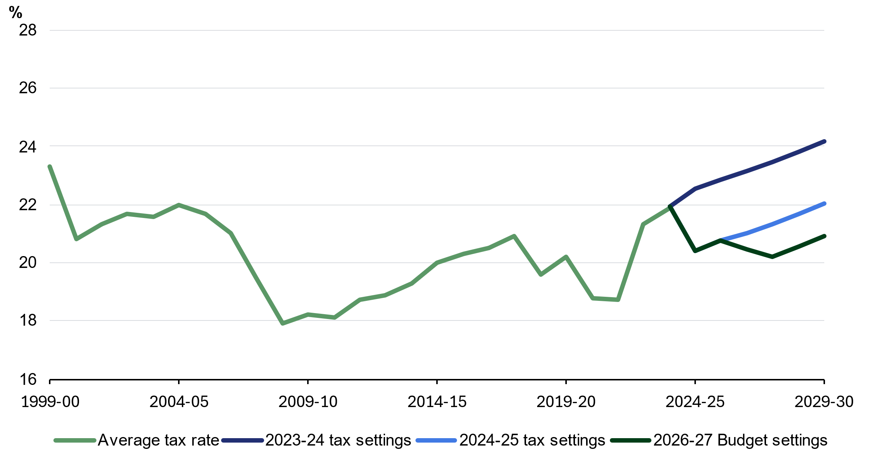

Note: Prior to 2026–27, the worker on average earnings is assumed to have taxable income equal to annualised estimates of average weekly earnings (AWE) after incorporating an annual deduction for work-related expenses of $359. From 2026–27 onwards, the worker’s taxable income is further reduced by the instant tax deduction (providing a tax benefit of $205). From 2027–28 the worker is assumed to benefit from the full Working Australians Tax Offset. Forecasts for AWE are as at the 2026–27 Budget. Average tax rate is defined as the ratio of tax payable to taxable income. Tax payable is calculated accounting for basic tax rates and thresholds and the Medicare levy.
Source: Treasury

Combined annual tax cut compared to 2023–24 tax settings
Income from work | 2026–27  Two tax cuts | 2027–28 onwards  Combined benefit with instant tax deduction | 2027–28 onwards  Three tax cuts + WATO | 2027–28 onwards  Combined benefit with instant tax deduction
Full-time national minimum wage – $49,296 | $1,179 | Up to $1,514 | $1,697 | Up to $2,032
Median income – $74,100 | $1,800 | Up to $2,120 | $2,318 | Up to $2,638
Average income – $81,245 | $1,978 | Up to $2,298 | $2,496 | Up to $2,816
Average full-time income – $106,657 | $2,613 | Up to $2,933 | $3,131 | Up to $3,451
Note: This table presents stylised cameos on the assumptions that an individual is an Australian tax resident, only has income from work and has work-related expenses of less than $1,000 from 2026–27. The reduction in tax liability is calculated by only taking into account the basic tax scales, Low Income Tax Offset (as applicable) and Medicare levy. The instant tax deduction benefit for an individual on the full-time national minimum wage includes additional benefit from the Low Income Tax Offset due to the reduction in their taxable income.
Source: Fair Work Ombudsman; ABS, Employee earnings, Aug 2025; ABS, Average Weekly Earnings, Nov 2025.

Key facts and figures
- After three rounds of tax cuts, the WATO and the instant tax deduction, an Australian worker on average earnings could receive a combined benefit of up to $2,816 from the 2027– 28 income year relative to 2023–24 tax settings.
- Around 13 million Australian workers, including 6.3 million women, will receive the WATO for the 2027–28 income year, of whom 97 per cent are expected to receive the full $250 offset.
- The Government’s combined tax cuts are lowering average tax rates for all working Australian taxpayers, with the average tax rates across all taxpayers falling from 25.5 per cent in 2023–24 to 24.7 per cent in 2027–28.
- The Government’s combined tax cuts are expected to keep average tax rates for an Australian worker on average earnings who receives the average benefit from the instant tax deduction below 2023–24 levels until 2032–33 – three years later than under 2024–25 settings.
- The WATO builds upon the Government’s already legislated tax cuts which are estimated to increase labour supply by 1.3 million hours per week, relative to 2023–24 settings.
- Around 6.2 million workers will benefit from the instant tax deduction with an average saving of $205 for 2026–27.

Combined annual tax cut compared to 2023–24 tax settings ($)
Income from work | 2026–27  Two tax cuts | 2027–28 onwards  Combined benefit with instant tax deduction | 2027–28 onwards  Three tax cuts + WATO | 2027–28 onwards  Combined benefit with instant tax deduction
20,000 | - | - | - | -
30,000 | 673 | Up to 923 | 1,041 | Up to 1,281
40,000 | 872 | Up to 1,092 | 1,340 | Up to 1,550
50,000 | 1,197 | Up to 1,532 | 1,715 | Up to 2,050
60,000 | 1,447 | Up to 1,782 | 1,965 | Up to 2,300
70,000 | 1,697 | Up to 2,017 | 2,215 | Up to 2,535
80,000 | 1,947 | Up to 2,267 | 2,465 | Up to 2,785
90,000 | 2,197 | Up to 2,517 | 2,715 | Up to 3,035
100,000 | 2,447 | Up to 2,767 | 2,965 | Up to 3,285
110,000 | 2,697 | Up to 3,017 | 3,215 | Up to 3,535
120,000 | 2,947 | Up to 3,267 | 3,465 | Up to 3,785
130,000 | 3,647 | Up to 3,967 | 4,165 | Up to 4,485
140,000 | 3,997 | Up to 4,387 | 4,515 | Up to 4,905
150,000 | 3,997 | Up to 4,387 | 4,515 | Up to 4,905
160,000 | 3,997 | Up to 4,387 | 4,515 | Up to 4,905
170,000 | 3,997 | Up to 4,387 | 4,515 | Up to 4,905
180,000 | 3,997 | Up to 4,387 | 4,515 | Up to 4,905
190,000 | 4,797 | Up to 5,187 | 5,315 | Up to 5,705
200,000 | 4,797 | Up to 5,267 | 5,315 | Up to 5,785
Note: This table presents stylised cameos on the assumptions that an individual is an Australian resident, only has income from work and has work-related expenses of less than $1,000 from 2026–27. The reduction in tax liability is calculated by only taking into account the basic tax scales, Low Income Tax Offset (as applicable) and Medicare levy. The tax cut benefit for an individual with taxable income of $30,000 includes the increase in the Medicare levy low-income thresholds from 2024–25 and 2025–26; their Medicare levy phases in at 10 cents per dollar above the Medicare levy low-income threshold. The instant tax deduction benefit for an individual with taxable income between $40,000 and $60,000 includes additional benefit from the Low Income Tax Offset due to the reduction in their taxable income.

