Backing small businesses to grow, compete and build resilience

Australian Government Small Business Statement

Supporting resilience and growth
Small businesses are the backbone of Australia’s economy. Around 2.7 million small businesses operate across the country, from local cafés and shops to tradies, farmers and professional services. They support jobs, families and communities in every region. Even with global volatility in recent years, small businesses have continued to show resilience, with more than 180,000 additional small businesses in operation since July 2022.
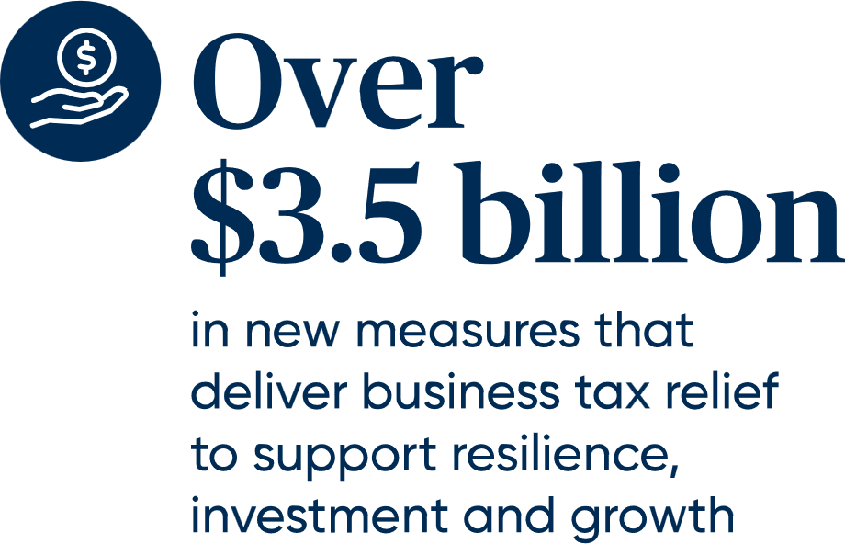
Global events, including the conflict in the Middle East, are contributing to higher global inflation, slower global growth and extreme economic uncertainty at home and abroad.
While Australia faces these complex challenges from a position of relative strength, small businesses are feeling these impacts directly as they contend with rising costs, supply chain pressures and slowing growth in consumer spending.
The Australian Government understands these challenges and is delivering practical, targeted and temporary measures that reduce immediate pressures, and permanent measures to help small businesses invest, innovate and grow. Tax relief, fairer competition and cutting red tape to lift productivity will help small businesses stay strong, adapt and grow in a changing world.
Tax reform and relief for small businesses
The Government’s tax reform package will support a more dynamic and resilient economy by helping businesses manage temporary shocks, invest and innovate through:
- making the $20,000 instant asset write-off permanent from 1 July 2026
- delivering a permanent two-year loss carry back for all companies up to $1 billion in turnover, from 1 July 2026
- introducing loss refundability to support start-up businesses invest and grow in their first two years of operation, capped to the value of tax remittances relating to employment, from 1 July 2028
- expanding tax incentives for venture capital to help unlock capital for young, expanding businesses
- reforming the Research and Development Tax Incentive, including allowing young businesses greater access to the refundable tax offset as they grow
- providing a $250 tax offset from 2027‍–‍28 for Australian workers, including around 1.5 million sole traders.

Supporting small businesses in challenging times
The Government will deliver an additional $8 million from 1 July 2026 to support the mental health and financial wellbeing of small business owners through the NewAccess for Small Business Owners program and the Small Business Debt Helpline.
The Government has introduced temporary, targeted measures to ease the pressure on small businesses affected by fuel disruptions by:
- delivering $2.9 billion in fuel excise relief and reducing the heavy vehicle road user charge to zero to support drivers and the transport sector
- providing interest-free loans from the National Reconstruction Fund’s $1 billion Economic Resilience Program to support eligible manufacturing and logistics businesses responding to market disruption
- granting temporary relief for businesses unable to meet tax obligations due to fuel supply disruptions
- extending the Small Business Responsible Lending Obligation exemption for a further ten years to support timely access to credit
- working with the finance sector and peak business bodies to support small business customers and suppliers
- establishing a National Fuel Security Plan to ensure supply chain resilience and keep the community and businesses updated on fuel security measures

- empowering the Fair Work Commission to make time-sensitive orders to help truck drivers and transport operators recover costs from higher fuel prices
- delaying cost recovery charges for agricultural exports, providing $8.2 million in relief to exporters
- empowering the Australian Competition & Consumer Commission (ACCC) with additional enforcement resources and maximum penalties of $100 million for businesses that unlawfully exploit consumers and small businesses.

Tax reforms to support small businesses to start, invest and grow

Permanent $20,000 instant asset write-off
The Government will simplify tax obligations for eligible small businesses by permanently extending the $20,000 instant asset write-off from 1 July 2026.
Small businesses with turnover of under $10 million will be able to immediately deduct eligible assets costing less than $20,000, helping with cash flow, investment and planning.
Permanently extending the $20,000 instant asset write-off will save small businesses around $32 million per year in compliance costs. Introducing dynamic monthly instalments and working to harmonise payroll tax administrative arrangements will further reduce time spent on record keeping, systems and procedures.
Coffee Co generates a $3,750 tax refund
Daniel and Eloise run a café through a company, Coffee Co Pty Ltd. The business generated $40,000 in taxable profits and paid $10,000 in tax in the 2025‍–‍26 income year (at the 25% tax rate).
To help grow the business, they are planning to purchase a new coffee machine for $19,000, new tables and chairs for $19,000 and outdoor heaters for $17,000. As a result of the permanent extension of the $20,000 instant asset write-off (IAWO), all these items can be immediately deducted.

Without these new investments, the café would have generated a $40,000 taxable profit. However, with the IAWO deductions, Coffee Co reports a $15,000 tax loss for the 2026‍–‍27 income year, paying no tax. Further, they will now be able to carry back that tax loss to the previous year's tax paid, generating a $3,750 tax refund ($15,000 x 25% tax rate). This provides timely cash flow to the business as it seeks to expand.

Further income tax cuts
The Government is introducing a new $250 Working Australians Tax Offset from 2027‍–‍28, providing an ongoing annual tax cut for over 13 million Australian workers, including sole traders. This is on top of the three rounds of tax cuts the Government has already legislated benefitting around 1.5 million sole traders.

Loss-refundability to support cash flow
The Government is improving the treatment of company tax losses.
From 2026‍–‍27, companies with turnover of up to $1 billion will be able to use their current year tax losses to claim a refund for the tax paid in the prior two income years.
This will benefit around 85,000 companies, with the majority being small businesses. For small businesses experiencing temporary losses, including where they are making investments to grow, this means additional cash flow to help fund their operations, wages and investments and return to profitability.
From 2028‍–‍29, small start-ups in their first two years of operation will be able to get a refund for tax losses, up to the amount of Fringe Benefits Tax and withholding tax paid on employee wages.

Tax reforms to support innovation
The Government is making it easier for start-ups to invest so they can grow and innovate. From 1 July 2027, the Government will expand venture capital incentives to reflect modern company valuations. This will give start-ups more opportunities to access venture capital funding, in larger amounts and over a longer period, particularly where traditional finance is harder to obtain.
From 1 July 2028, the Government will reform the Research and Development Tax Incentive to make it better targeted and easier to use, incentivising a further $400 million in research and development (R&D) by young businesses each year.
- The Government will increase the offset for experimental ‘core’ R&D by around 25 to 50 per cent and remove eligibility for R&D supporting expenditure. This will simplify and better target R&D support for businesses.
- The Government will provide greater support to young, fast-growing businesses by increasing the turnover threshold for the higher, refundable offset to $50 million. Refundability will be available to businesses operating for less than 10 years, with older businesses eligible for an equivalent, non-refundable offset.
- For smaller research and development projects of under $50,000, the Government will require businesses to work with recognised research organisations to support quality research outcomes.
The Government will use savings from these changes to help fund tax reforms that support innovation and investment by small businesses.


Tax changes to improve fairness
The Government is making the tax system fairer and more sustainable for all Australians by introducing a 30 per cent minimum tax on discretionary trusts from 1 July 2028. The Government will exclude primary production income such as income from agriculture, and other types of trusts such as fixed trusts and charitable trusts.
New, time-limited rollover relief will be available for three years from 1 July 2027 to support small businesses that wish to restructure to other entity types. The Australian Small Business and Family Enterprise Ombudsman (ASBFEO) will be available to assist small business understand the options available to them and where they can get further advice. The Australian Securities and Investments Commission will put in place specific arrangements to support small businesses that wish to incorporate.
Small businesses that restructure to a corporate structure will gain access to a range of benefits like the 25 per cent small business tax rate, dividend imputation and easier processes to retain earnings for working capital.
The Government will also maintain existing CGT concessions for small businesses, allowing them to halve or completely disregard CGT on the sale of eligible assets.

A better operating environment
The Government is cutting red tape, simplifying rules and lowering compliance costs.

Making it easier to trade
This Budget builds on previous reforms by removing another 497 nuisance tariffs – saving businesses around $127 million in compliance costs per year and strengthening our trade remedies system. The Government will also consult on abolishing additional tariffs to further cut costs for Australian businesses.
The Government is also lowering barriers to trade through the Australia–EU Free Trade Agreement. The Budget provides $7.6 million over four years to expand the Australian Trusted Trader program – reducing red tape at the border and making it faster and easier for more small businesses to export. Small businesses will be able to seize low‑carbon growth opportunities through $7.7 million over four years in new funding under the Singapore – Australia Green Economy Agreement.

Regulatory Reform Agenda
Through the Regulatory Reform Agenda, the Government is reducing unnecessary regulatory burden and modernising outdated requirements. These include:
- delivering $10.2 billion a year in regulatory burden reduction

- implementing new legislative reform and the Council of Financial Regulators’ Better Regulation Roadmap to improve efficiency and reduce compliance costs in the financial sector
- reducing paperwork through a tell-us-once approach, so businesses don’t have to provide the same information to Government multiple times
- reviewing regulatory barriers to business dynamism through a Productivity Commission inquiry.
The Government is further supporting business cash flow by making it easier for businesses to change their monthly pay as you go instalments when business conditions change, by:
- allowing small businesses to opt in to monthly reporting and payment from 1 July 2027
- enabling small businesses to opt in to dynamic pay as you go instalment calculations, allowing them to adjust quickly to real-time business conditions, providing better cash flow certainty
- the Australian Taxation Office (ATO) removing interest charges for businesses that accidentally get their instalment variation wrong when using ATO-approved calculators.
The Government is also targeting compliance burden through the ASBFEO led White Tape Review and the Board of Taxation Red Tape Reduction Review.

Healthy competition and fairer markets
The Government continues to promote healthy competition through a range of reforms and programs so that small businesses get a fair go.
- Empowering the ACCC to protect small businesses doing the right thing by doubling maximum penalties for anti-competitive and anti-consumer conduct under the Competition and Consumer Act 2010 and Australian Consumer Law, from $50 million to $100 million.
- Supporting Fresh Produce Suppliers – Food and Grocery Code Education Program, commencing in 2026, to help smaller suppliers develop the skills and confidence to negotiate fairer deals with major supermarkets.
- Ensuring the protection of small businesses, including franchisees, from unfair trading practices and unfair contract terms.
- Free access to mandatory standards, which will save some small businesses over $1,600 a year.
- Delivering National Competition Policy reforms, estimated to lift long run GDP by around $13 billion a year including harmonising occupational licensing, commercial planning and zoning, modern methods of construction, heavy vehicle regulations and care worker screening, as well as seeking to work with states and territories to reduce the regulatory burden associated with retail tenancies, regulation of agricultural and veterinary chemicals and payroll tax administration.

- Strengthening Australia’s product safety rules including new safety obligations for international and domestic online marketplaces, levelling the playing field with brick-and-mortar businesses.
- Encouraging faster payment times for small business suppliers through increased transparency, new reputational incentives and enhanced regulatory powers under the overhauled Payment Times Reporting Scheme.
- Extending the right to repair to agricultural machinery will reduce downtime and costs for farmers.
The Government is providing an additional $1.3 million to the Fair Work Commission to continue to provide specialised supports for small businesses. This helps small businesses navigate the Commission’s processes, including in workplace disputes, which can present unique challenges for small businesses.
The Government is also investing $62 million to extend the operation of the Consumer Data Right, including to help small businesses better understand their finances and access more competitive products and services.
New Australian Small Business and Family Enterprise Ombudsman
The Australian Government has continued in its commitment to levelling the playing field for small businesses by appointing Ms Lynda McAlary-Smith, a highly experienced small business dispute resolution expert, as the independent ASBFEO.

Digital adoption and skills
This Budget builds on productivity and growth reforms implemented in recent Budgets, and includes measures to encourage innovation, digital uplift and greater access to workers with the right skills.

Skills
The Government is making it easier for small businesses to find the right skills they need to grow and address labour shortages. This Budget includes:
- making it quicker to recognise the skills of migrant trades workers and to accelerate occupational licensing – cutting the time taken to enter the workforce by up to 6 months
- reforms to the Australian Apprenticeships Incentive System, including prioritising employer incentives to small and medium employers and Group Training Organisations from 1 January 2027.

Digital adoption
The Government continues to support small businesses to adopt digital tools that improve efficiency, reduce costs and gain access to new markets.
The National AI Plan, released on 2 December 2025, establishes the settings that will ensure AI delivers for all Australians, including small businesses.

On 8 May 2026, the National Artificial Intelligence Centre launched AI.gov.au – the Government’s front door for AI resources and guidance, focusing on the needs of small-to-medium enterprises and not-for-profits.
Round 3 of the Digital Solutions program, launching on 1 July 2026, will offer coaching, workshops and webinars for small businesses, with a new focus on AI and emerging technologies.
Digital Solutions – Shirley Wu Jewellery
Shirley used Digital Solutions to improve the website and marketing for her business.
Through one-on-one mentoring and workshops, she learned how to develop a marketing strategy and advertise effectively.
After launching a new website and introducing a weekly social media schedule, Shirley saw a rapid growth in views and interactions, leading to increased bookings for her jewellery making workshops.
Shirley’s advice to other business owners is clear: ‘Don’t underestimate the power of a strong digital strategy.’
As part of the 2023 ‍–‍2030 Australian Cyber Security Strategy – Horizon 2 the Government will provide $89.3 million to sustain and enhance cyber security initiatives, including initiatives that target or benefit small businesses.

Working with you
Small businesses are an enduring priority for the Australian Government. The Government is engaging directly with small businesses, including through its newly appointed Small Business Consultative Group.
The Government will also continue to work closely with the States and Territories through the Council on Federal Financial Relations, the National Small Business Strategy and Small Business Ministers’ Meetings, as well as with regulators, business groups, chambers of commerce and the community.

Together, this coordinated approach will help ensure Australia’s small businesses remain resilient, competitive and well placed for future growth.

