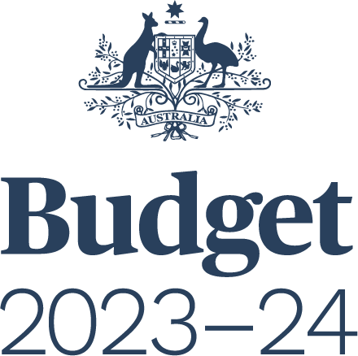

FEDERAL FINANCIAL RELATIONS
BUDGET PAPER NO. 3

Circulated by
The Honourable Jim Chalmers MP
Treasurer of the Commonwealth of Australia
and
Senator the Honourable Katy Gallagher
Minister for Finance, Minister for Women,
Minister for the Public Service of the Commonwealth of Australia

For the information of honourable members
on the occasion of the Budget 2023–24
9 May 2023

© Commonwealth of Australia 2023
ISSN 0728 7194 (print); 1326 4133 (online)
This publication is available for your use under a Creative Commons BY Attribution 3.0 Australia licence, with the exception of the Commonwealth Coat of Arms, third-party content and where otherwise stated. The full licence terms are available from http://creativecommons.org/licenses/by/3.0/au/legalcode.
Use of Commonwealth of Australia material under a Creative Commons BY Attribution 3.0 Australia licence requires you to attribute the work (but not in any way that suggests that the Commonwealth of Australia endorses you or your use of the work).
Commonwealth of Australia material used ‘as supplied’.
Provided you have not modified or transformed Commonwealth of Australia material in any way including, for example, by changing the Commonwealth of Australia text; calculating percentage changes; graphing or charting data; or deriving new statistics from published statistics – then the Commonwealth of Australia prefers the following attribution:
Source: The Commonwealth of Australia.
Derivative material
If you have modified or transformed Commonwealth of Australia material, or derived new material from those of the Commonwealth of Australia in any way, then the Commonwealth of Australia prefers the following attribution:
Based on Commonwealth of Australia data.
Use of the Coat of Arms
The terms under which the Coat of Arms can be used are set out on
the Department of the Prime Minister and Cabinet website (see www.pmc.gov.au/
honours-and-symbols/commonwealth-coat-arms).
Other uses
Enquiries regarding this licence and any other use of this document are welcome at:
Manager
Media Unit
The Treasury
Langton Crescent
Parkes ACT 2600
Email: media@treasury.gov.au
Internet
A copy of this document is available on the central Budget website at: www.budget.gov.au.
Printed by CanPrint Communications Pty Ltd.

Foreword
This Budget Paper presents information on the Australian Government’s financial relations with state, territory and local governments.

Contents
Foreword iii
Part 1: Australia’s Federal Relations 1
Overview 1
Australian Government funding to the states 3
Measures affecting payments to the states 9
Part 2: Payments for specific purposes 13
Overview 13
Health 17
Education 39
Skills and workforce development 46
Community services 50
Affordable housing 56
Infrastructure 59
Environment, energy and water 72
Contingent payments 95
Other payments 97
Part 3: General revenue assistance 109
Overview 109
GST payments 109
Other general revenue assistance 114
Mirror tax arrangements 115
Appendix A: Parameters and further information 117
Population 117
Data sources 119
Further information 120
Notes 121

List of tables
Table 1.1: Australian Government payments to the states, 2022–23 to
2026–27 6
Table 1.2: Total Australian Government payments to the states as a proportion of GDP 7
Table 1.3: Australian Government’s contribution to state expenditure 8
Table 1.4: Measures affecting payments to the states 9
Table 2.1: Total payments for specific purposes by category, 2022–23 to 2026–27 14
Table 2.2: Payments for specific purposes by sector and category, 2022–23 to 2026–27 16
Table 2.3: Payments to support state health services 17
Table 2.3.1 Health services 20
Table 2.3.2 Health infrastructure 29
Table 2.3.3 First Nations health 33
Table 2.3.4 Other health National Partnership payments 35
Table 2.4: Payments to support state education services 39
Table 2.5: Payments to support state skills and workforce development services 46
Table 2.6: Payments to support state community services 50
Table 2.7: Payments to support state affordable housing services 56
Table 2.8: Payments to support state infrastructure services 59
Table 2.9: Payments to support state environment, energy and water services 72
Table 2.10: Contingent payments to the states 95
Table 2.11: Payments to support other state services 97
Table 3.1: General revenue assistance 109
Table 3.2: Reconciling GST revenue, GST entitlement and GST payments to the states 111
Table 3.3: Reconciliation of the GST entitlement estimates since the October Budget 111
Table 3.4: Policy decisions since the October Budget that affect the GST entitlement 112
Table 3.5: Calculation of GST entitlements 113
Table 3.6: Reconciliation of the GST administration budget 114
Table 3.7: Other general revenue assistance 114
Table 3.8: Mirror taxes accrued on behalf of the states 115
Table A.1: Population by state, at 31 December 117
Table A.2: Population by state, at 30 June 117
Table A.3: Total fertility rate, for years ending 30 June 118
Table A.4: Projected life expectancy at birth, for years ending 30 June 118
Table A.5: Net overseas migration, for years ending 30 June 118
Table A.6: Net interstate migration by state, for years ending 30 June 119
Table A.7: Wage cost indices 119

List of charts
Chart 1.1: Payments for specific purposes 2023–24, by sector 4
Chart 1.2: Total Australian Government payments to the states, 2023–24 7

