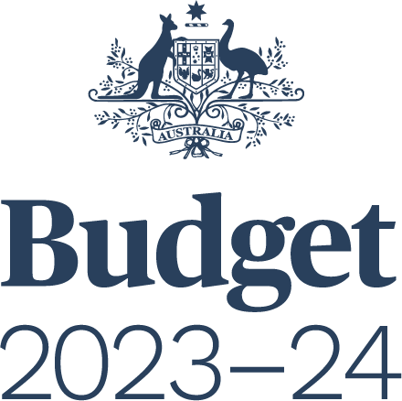

BUDGET STRATEGY AND OUTLOOK
BUDGET PAPER NO. 1

Circulated by
The Honourable Jim Chalmers MP
Treasurer of the Commonwealth of Australia
and
Senator the Honourable Katy Gallagher
Minister for Finance, Minister for Women, Minister for the Public Service
of the Commonwealth of Australia

For the information of honourable members
on the occasion of the Budget 2023–24
9 May 2023

© Commonwealth of Australia 2023
ISSN 0728 7194 (print); 1326 4133 (online)
This publication is available for your use under a Creative Commons BY Attribution 3.0 Australia licence, with the exception of the Commonwealth Coat of Arms, third-party content and where otherwise stated. The full licence terms are available from http://creativecommons.org/licenses/by/3.0/au/legalcode.
Use of Commonwealth of Australia material under a Creative Commons BY Attribution 3.0 Australia licence requires you to attribute the work (but not in any way that suggests that the Commonwealth of Australia endorses you or your use of the work).
Commonwealth of Australia material used ‘as supplied’.
Provided you have not modified or transformed Commonwealth of Australia material in any way including, for example, by changing the Commonwealth of Australia text; calculating percentage changes; graphing or charting data; or deriving new statistics from published statistics — then the Commonwealth of Australia prefers the following attribution:
Source: The Commonwealth of Australia.
Derivative material
If you have modified or transformed Commonwealth of Australia material, or derived new material from those of the Commonwealth of Australia in any way, then the Commonwealth of Australia prefers the following attribution:
Based on Commonwealth of Australia data.
Use of the Coat of Arms
The terms under which the Coat of Arms can be used are set out on
the Department of the Prime Minister and Cabinet website (see www.pmc.gov.au/
honours-and-symbols/commonwealth-coat-arms).
Other uses
Enquiries regarding this licence and any other use of this document are welcome at:
Manager
Media Unit
The Treasury
Langton Crescent
Parkes ACT 2600
Email: media@treasury.gov.au
Internet
A copy of this document is available on the central Budget website at: www.budget.gov.au.
Printed by CanPrint Communications Pty Ltd.
Contents
Statement 1: Budget Overview 1
Economic and Fiscal Outlook 5
Budget priorities 9
Statement 2: Economic Outlook 39
Outlook for the international economy 43
Outlook for the domestic economy 56
Statement 3: Fiscal Strategy and Outlook 81
Economic and Fiscal Strategy 87
Fiscal outlook 92
The Government’s balance sheet 110
Fiscal impacts of climate change 119
Appendix A: Other fiscal aggregates 128
Statement 4: Structural Shifts Shaping the Economy 133
Structural shifts shaping the economy 137
A growing care and support economy 141
Technological and digital transformation 148
Climate change and the net zero transformation 153
Making the most of structural shifts 161
Statement 5: Revenue 163
Overview 167
Variations in receipts estimates 171
Tax receipts estimates 172
Variations in revenue estimates 186
Appendix A: Tax Expenditures 189
Statement 6: Expenses and Net Capital Investment 193
Overview 197
Estimated expenses by function 200
General government sector expenses 204
General government net capital investment 230

Statement 7: Debt Statement 239
Australian Government Securities on issue 243
Non-resident holdings of AGS on issue 248
Net debt 249
Interest on AGS 251
Appendix A: AGS issuance 253
Appendix B: Interest on AGS 254
Statement 8: Forecasting Performance and Sensitivity Analysis 255
Assessing past forecasting performance 259
Assessing forecast uncertainty – confidence interval analysis 266
Assessing current forecasts through sensitivity analysis 270
Statement 9: Statement of Risks 275
Risks to the Budget – Overview 279
Agriculture, Fisheries and Forestry 288
Attorney-General’s 290
Climate Change, Energy, the Environment and Water 292
Defence 295
Employment and Workplace Relations 297
Finance 299
Foreign Affairs and Trade 303
Health and Aged Care 304
Home Affairs 308
Industry, Science and Resources 311
Infrastructure, Transport, Regional Development, Communications and the Arts 314
Prime Minister and Cabinet 320
Social Services 321
Treasury 323
Veterans’ Affairs 330
Government loans 331
Statement 10: Australian Government Budget Financial Statements 347
Appendix A: Financial reporting standards and budget concepts 383
Appendix B: Assets and Liabilities 391
Statement 11: Historical Australian Government Data 405
Data sources 409
Comparability of data across years 409
Revisions to previously published data 411
Notes 433

